**MACHINE LEARNING**

### Submitted By

**MEHTA NIKI BHAVESHKUMAR ENROLLMENT NO. 195693693009**

**5TH SEMESTER SUBJECT CODE-46593023**

### Of

**MASTER OF COMPUTER APPLICATIONS**



**GOVERNMENT MCA COLLEGE MANINAGAR (EAST), AHMEDABAD GUJARAT**

**[Academic Year: 2020-21]**

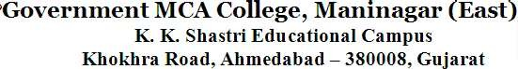



# Date:

**C ERTIFICATE**

This is to certify that **MEHTA NIKI BHAVESHKMAR (ENROLLMENT NO. 195693693009), Student** of **MCA 5TH Semester**, **Government MCA College** Has Successfully completed his practical work of subject **MACHINE LEARNING (4659302)**.

### DATE OF SUBMISSION:

**Prof. Darshankumar Modi Assistant Professor Government MCA College, Maninagar ,Ahmedabad**

INDEX

|  |  |
| --- | --- |
| No. | Title |
| 1 | Write a python code to implement **decision tree** for below given dataset. Identify the root node and all subpart or children of node and draw the tree. |
| 2 | Write a python code to implement **K-nearest neighbourhood** program for the given dataset. Assume that value of K=19. |
| 3 | Write a python code to implement Apriori **a**lgorithm, apply join and prune method and find frequent itemset |
| 4 | Write a python code to apply **Naive Bayesian** algorithm to classify that whether a person can buy computer or not based on given test data : |
| 5 | Given the below training dataset of petal size and flower type, predict flower type for petal of size 2.5 cm. using K-Nearest-Neighbor classification. |
| 6 | Consider the below training data and determine if jacket is to be worn when the temperature is 12-degree Celsius using Linear Regression Model. |
| 7 | Implement a python program that takes interest rate (x), finds the equation that best fits the data and is able to forecast out median home price for given interest rate using the data given below. (Use linear regression) |
| 8 | Write a python code to predict the price of house given square feet and number of bed rooms in the house for the dataset available at |
| 9 | Implement supervised machine learning algorithm (Classification Support Vector Machine) in python to classify breast tumour data into  malignant breast tumour or benign breast tumour (use breast tumour dataset) and obtain its accuracy level. |
| 10 | Write a python program to build an email spam classifier using support vector machines for the Spam base dataset from UCI machine learning repository. |
| 11 | Implement unsupervised machine learning algorithm (Clustering K Means) in python on Titanic dataset to cluster data (use Titanic dataset) by  removing the class label. |
| 12 | Implement unsupervised machine learning algorithm (Clustering K Means) in python on Breast Tumour dataset to cluster data (use Breast  Tumour dataset) by removing the class label. |

|  |  |
| --- | --- |
| 13 | Implement unsupervised machine learning algorithm (Clustering Hierarchical) in python on Titanic dataset to cluster data (use Titanic dataset). |
| 14 | Implement Apriori algorithm in python to find rules which explain association between different products for given transactions at a retail store. |
| 15 | Implement supervised machine learning algorithm (Classification - Naïve Bayes algorithm) in python/R on Pima Indians Diabetes dataset and obtain its accuracy level. |
| 16 | Implement unsupervised machine learning algorithm (Clustering K Means) in python. |
| 17 | Implement machine learning algorithm of Perception Learning in Artificial Neural Networks. |
| 18 | Implement machine learning algorithm of Multilayer feedforward in Artificial Neural Networks. |

**Aim-1:** Write a python code to implement **decision tree** for below given dataset. Identify the root node and all subpart or children of node and draw the tree.

# IMPORTING NECESSARY LIBRARY AND REPRESENTING A DATASET:

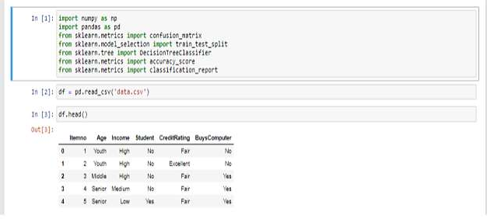

# Transforming a String Values to Numeric:

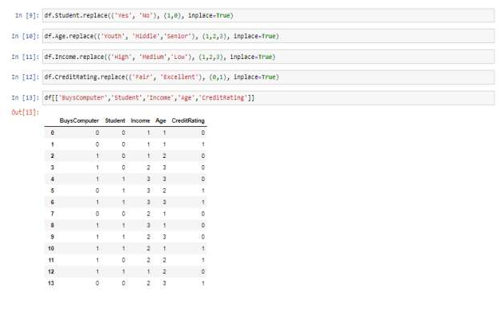

5



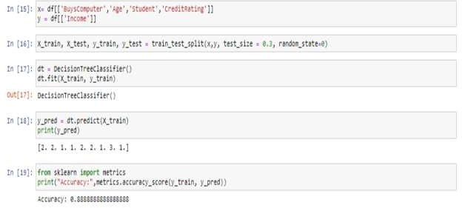

# Visualisation of Decision Tree:

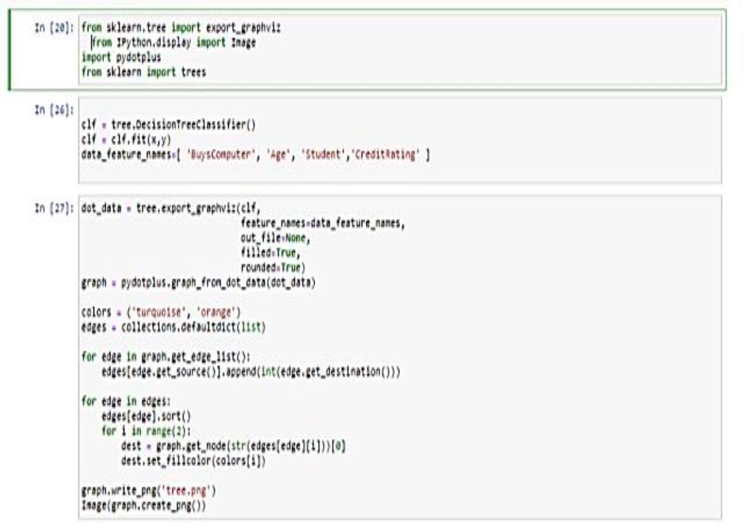

6

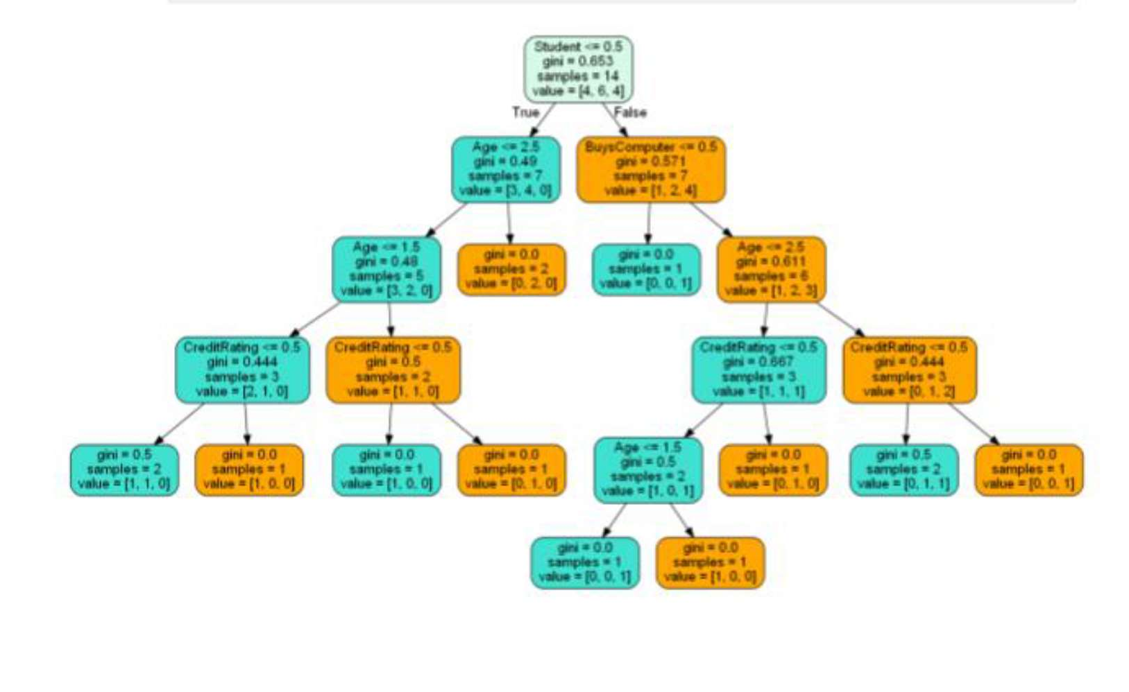

## Aim-2: Write a python code to implement **K-nearest neighbourhood** program for the given dataset. Assume that value of K=19.

# IMPORTING NECESSARY LIBRARY AND REPRESENTING A DATASET:

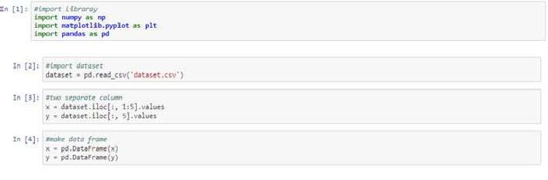

# DATA CLEAN

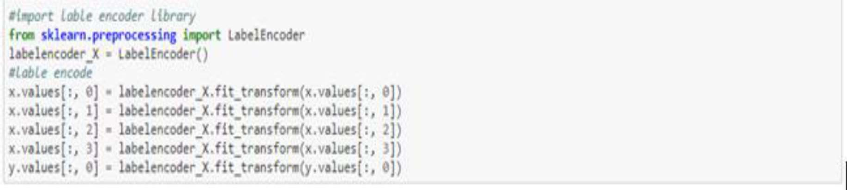

7

# SPILLTING DATASET IN TO TRAINING AND TEST SET.

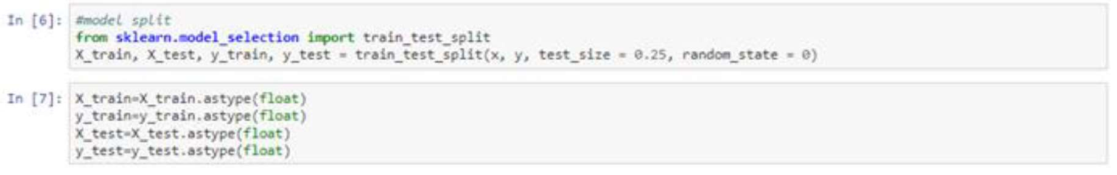

# FEATURE SCALING



# FITTING KNN IN TO TRAINING SET

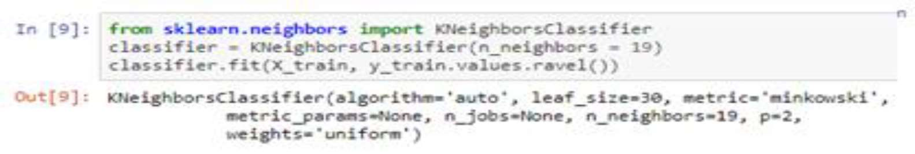

# PREDICTING THE TEST CASE RESULTS

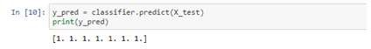

# ACCURACY RESULT

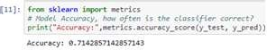

# CONFUSION MATRIX

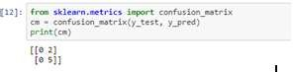

## Aim-3: Write a python code to implement Apriori **a**lgorithm, apply join and prune method and find frequent itemset

# IMPORTING NECESSARY LIBRARY AND REPRESENTING A DATASET:

8

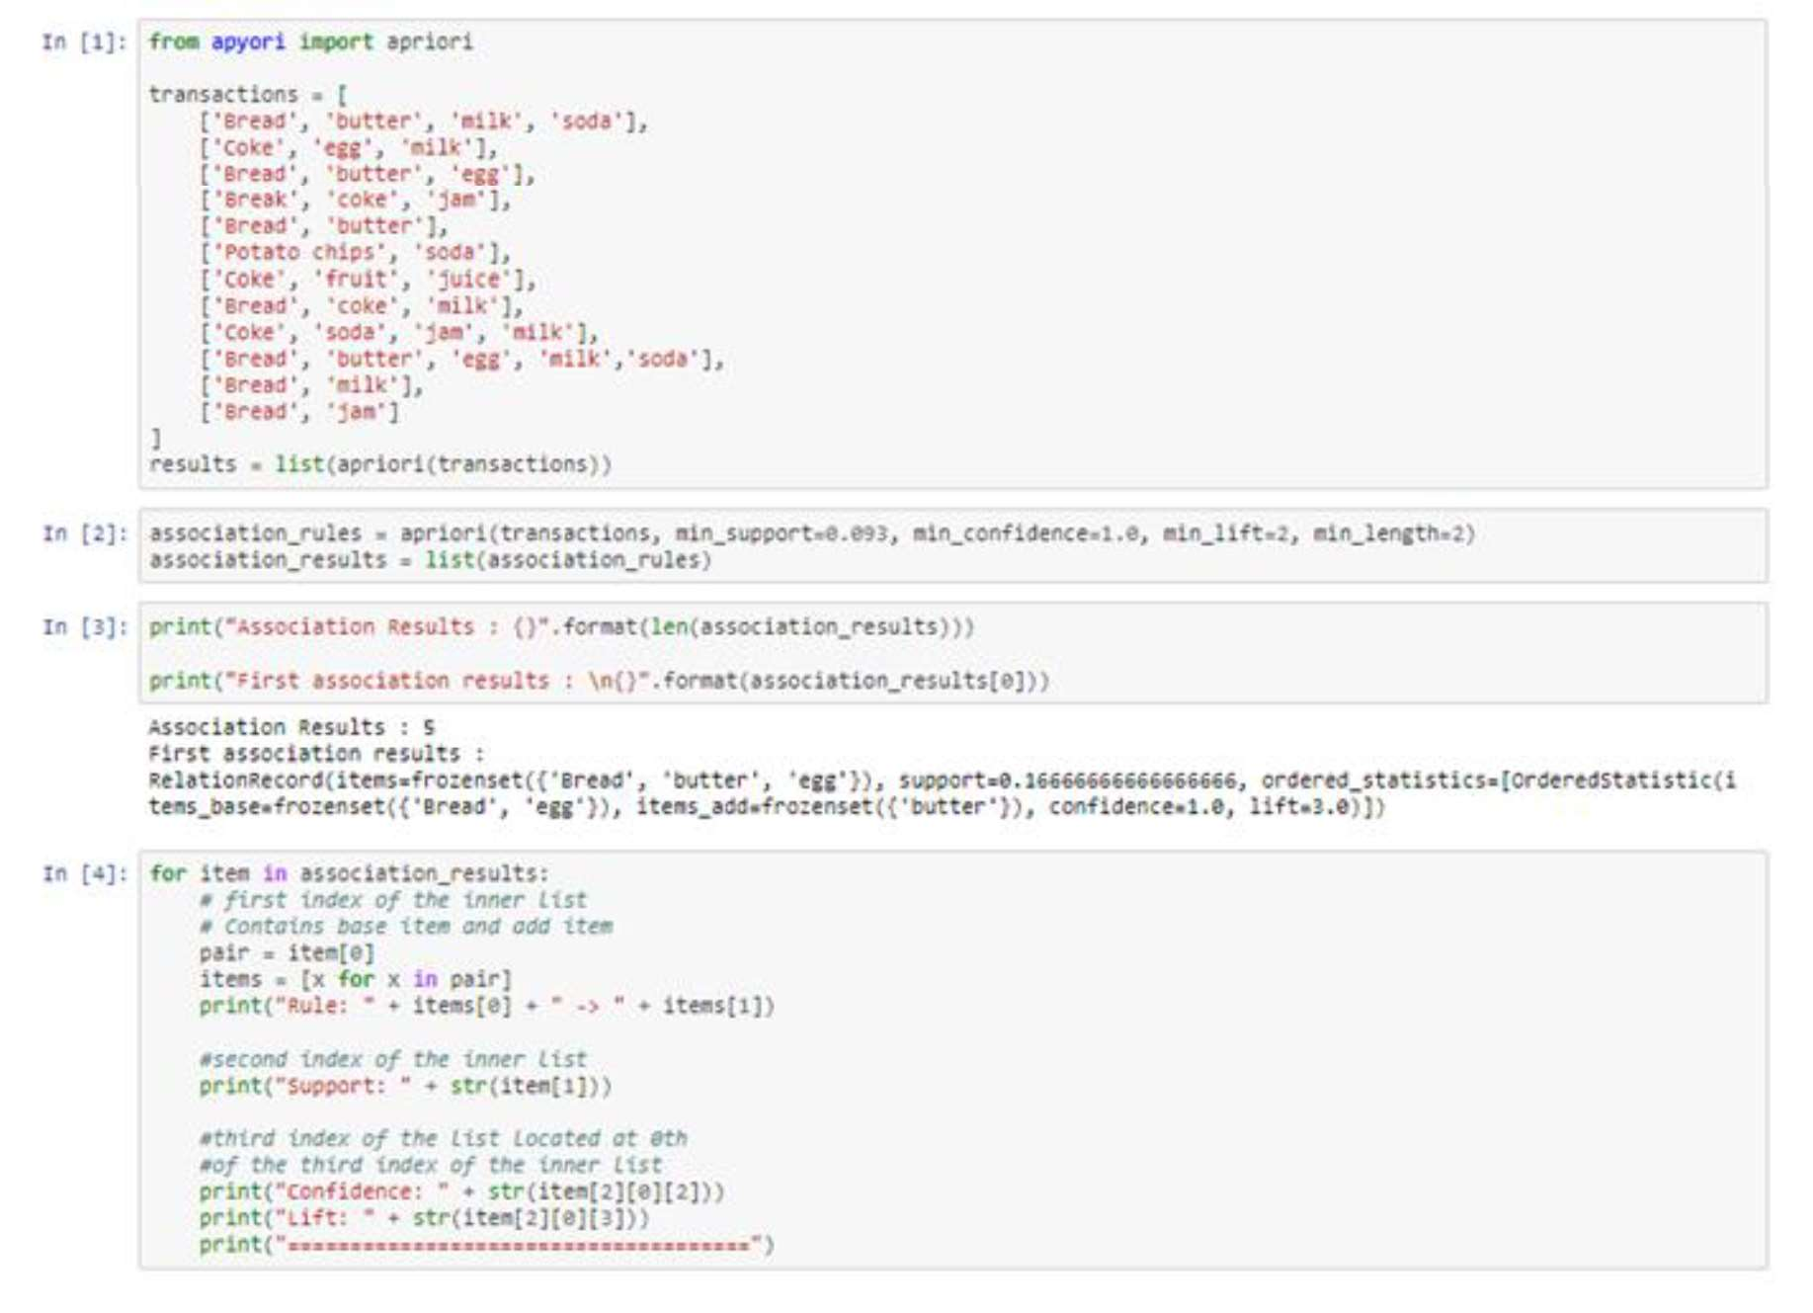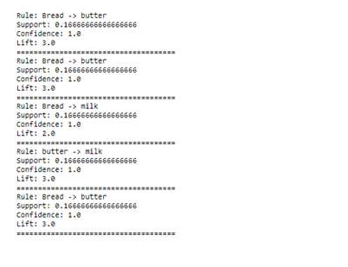

## Aim-4: Write a python code to apply Naive Bayesian algorithm to classify that whether a

person can buy computer or not based on given test data .

# IMPORTING NECESSARY LIBRARY :



9

# REPRESENTING A DATASET:

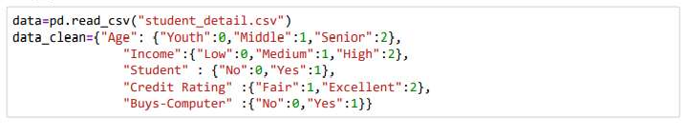

# DATACLEAN:

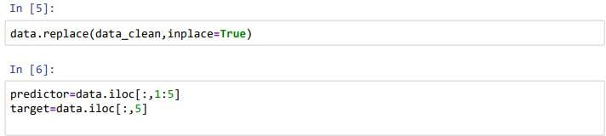

# TRAINING A MODEL:

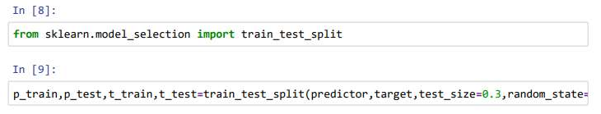

# MODEL FITTING AND APPLYING NAÏVE BAYES:

10

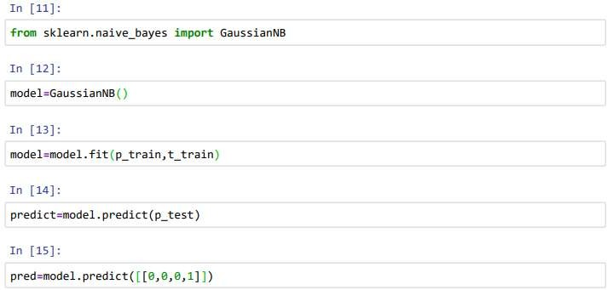

# FINAL PREDICTION:

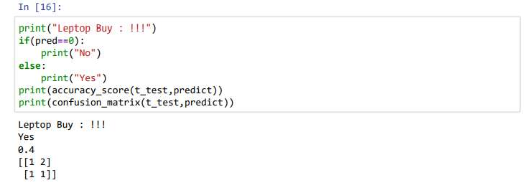

## Aim-5: Given the below training dataset of petal size and flower type, predict flower type for petal of size 2.5 cm. using K-Nearest-Neighbor classification.

# IMPORTING LIBRARIES:

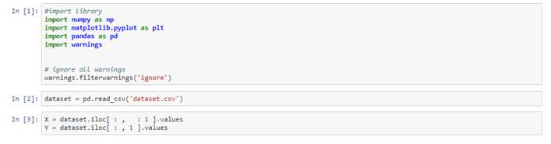

# SPILITING A DATASET:

11



# FEATURE SCALING:



# FITTING A KNN TO THE TRAINING SET:

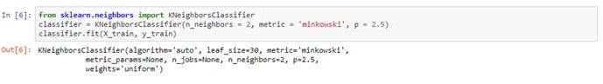

# PREDICTING A RESULT:



# CONFUSION MATRIX:

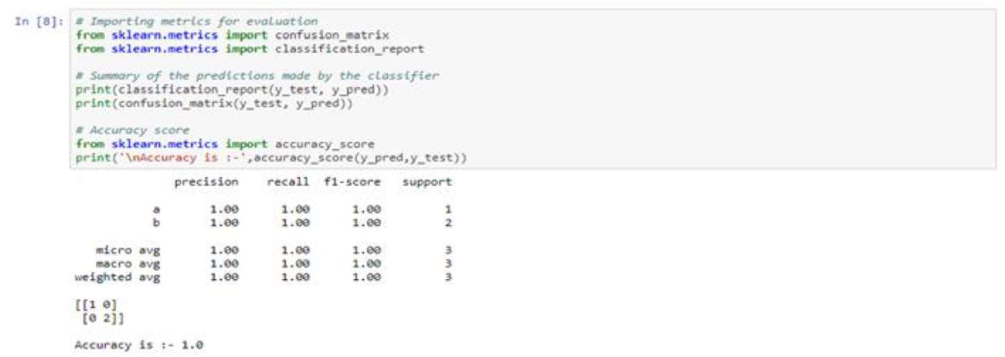

## Aim-6: Consider the below training data and determine if jacket is to be worn when the temperature is 12-degree Celsius using Linear Regression Model.

|  |  |
| --- | --- |
| **Outside Temperature** | **Wear a Jacket** |
| **30°C** | **No** |
| **25°C** | **No** |
| **20°C** | **No** |
| **15°C** | **Yes** |
| **10°C** | **Yes** |

12

# IMPORTING LIBRARIES:

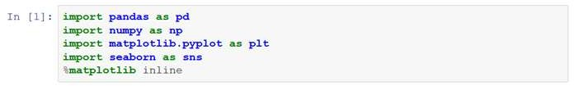

# TRAINING ,TESTING & FITTING A MODEL :

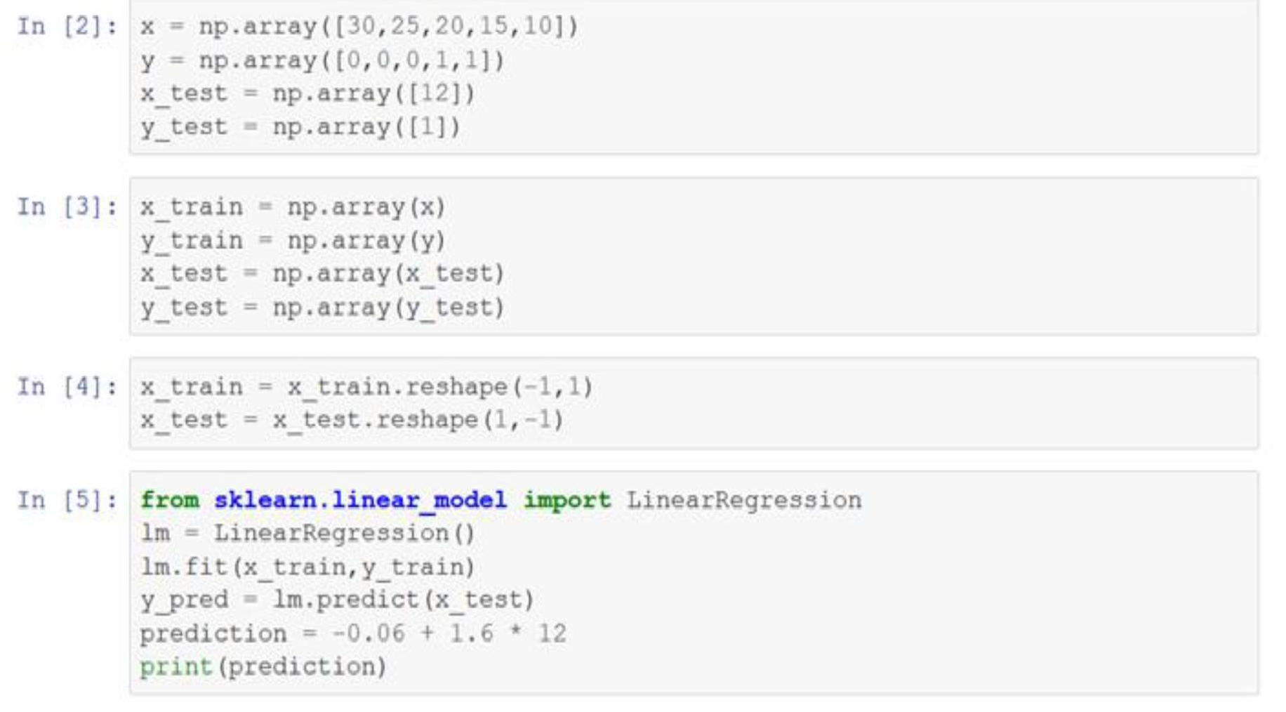

# PREDICTION AND OUTLIERS PLOTTING :

13

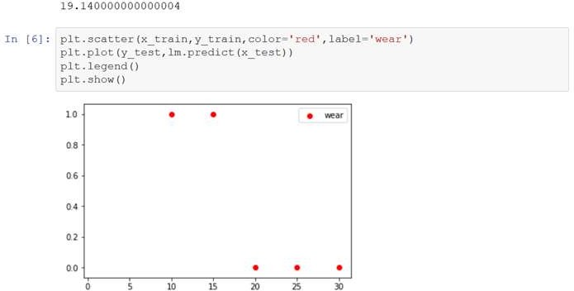

# FINAL PREDICTION:

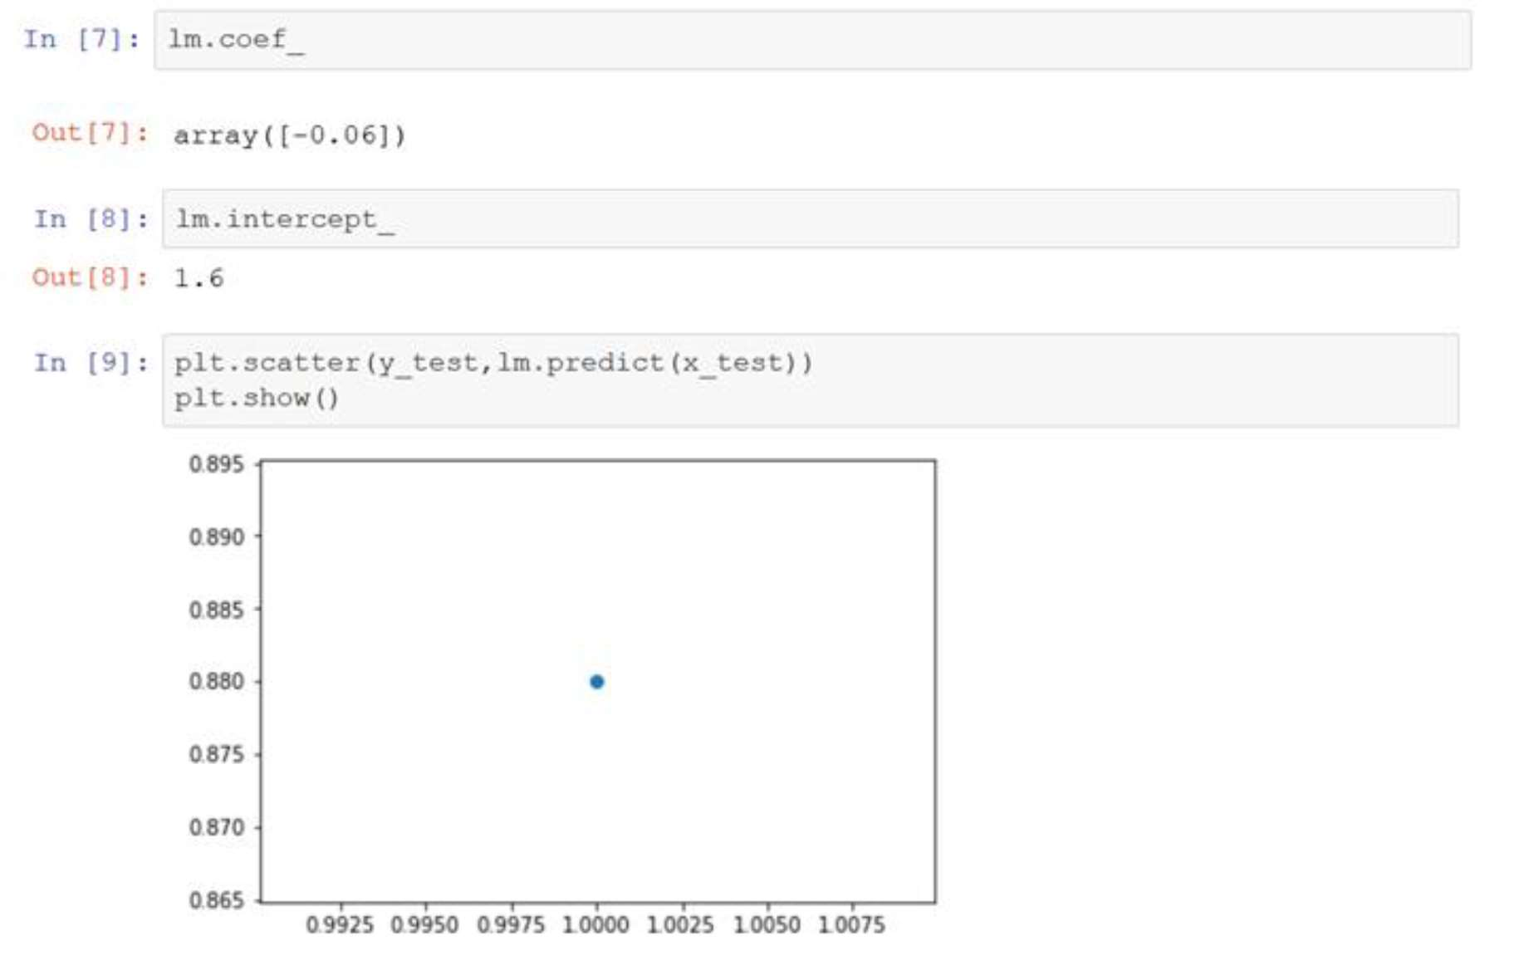

14

## Aim-7: Implement a python program that takes interest rate (x), finds the equation that best fits the data and is able to forecast out median home price for given interest rate using the data given below. (Use linear regression).

# IMPORTING LIBRARY & DATASET:

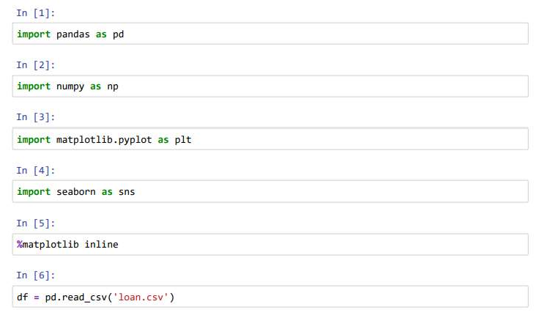

# REPRESENTING A TOP 5 DATA:

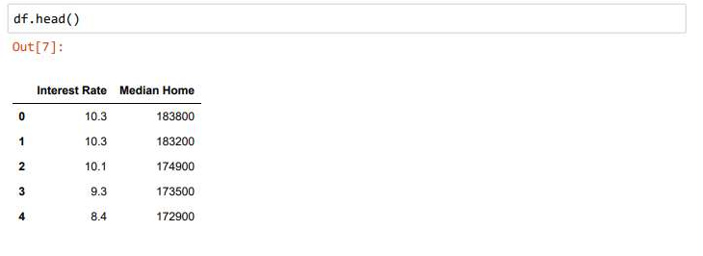

# REPRESENTING INTEREST RATE BY MEDIAN HOME:

15

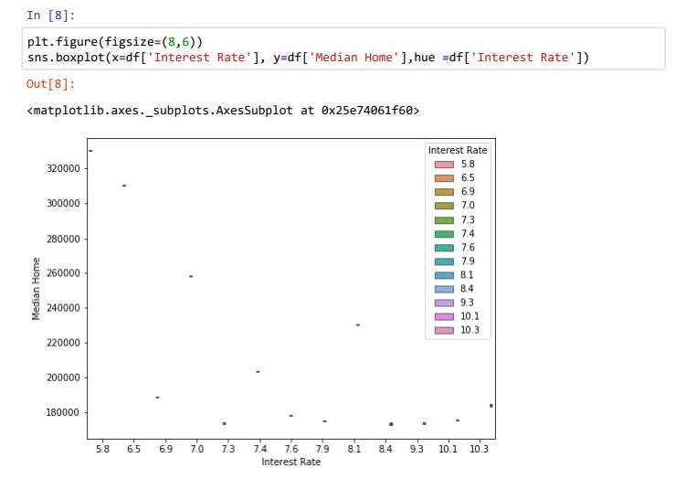

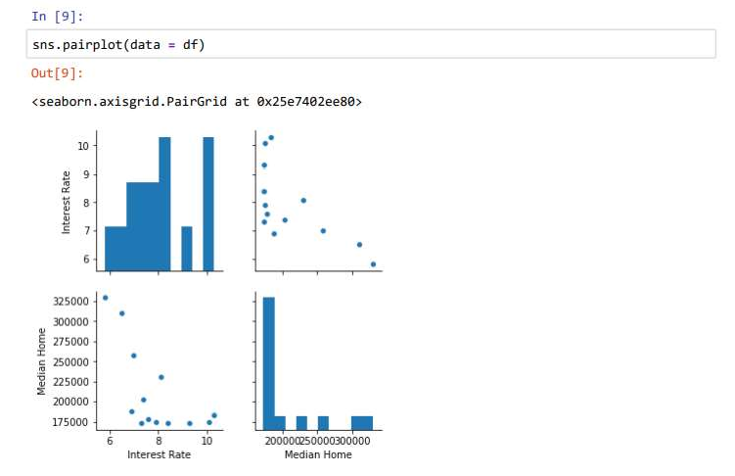

16

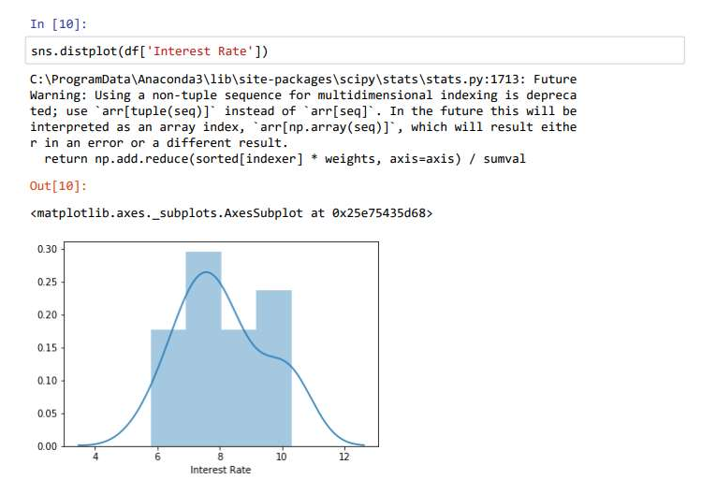

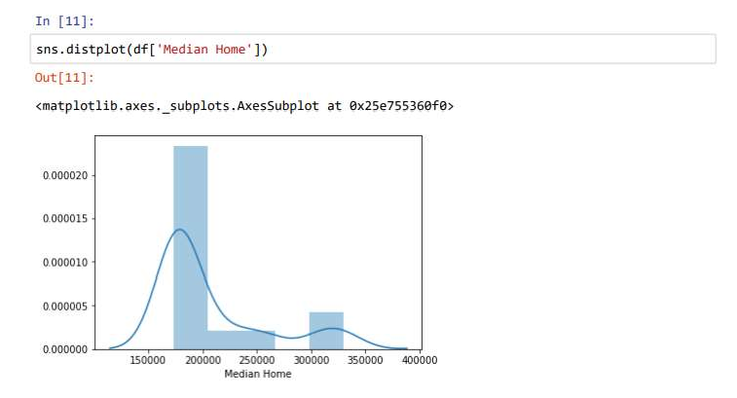

# MODEL TRAINING:

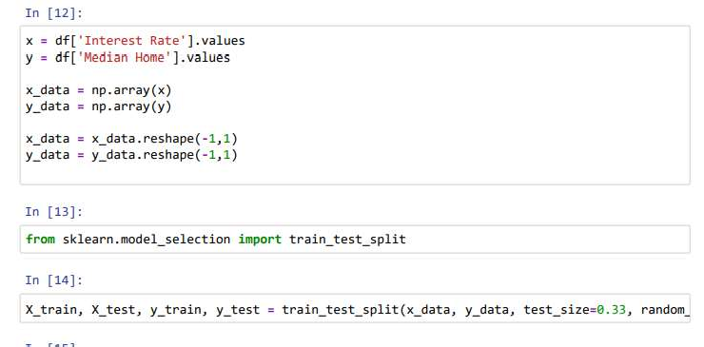

17

# APPLYING A LINEAR REGRESSION:

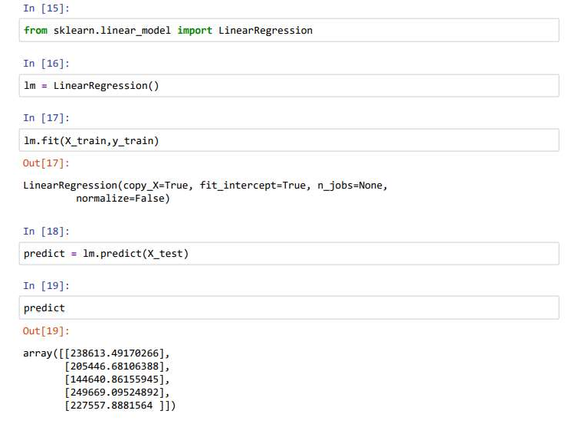

# FINAL OUTPUT EQUATION:

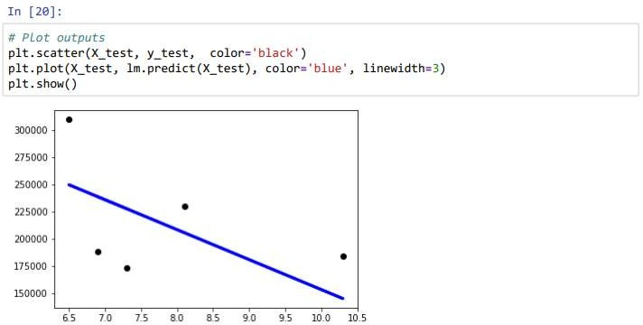

## Aim-8: Write a python code to predict the price of house given square feet and number of bed rooms in the house for the dataset available at link.

18

# IMPORTING LIBRARY & DATA PREPROCESSING:

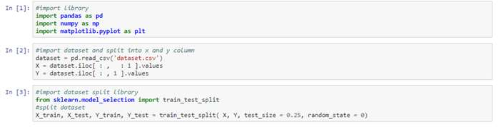

# FITTING SIMPLE LINEAR REGRESSION MODEL TO TRAINING SET:

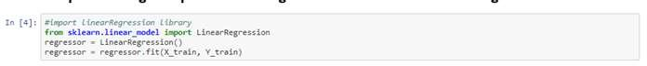

# RESULT PREDICTION

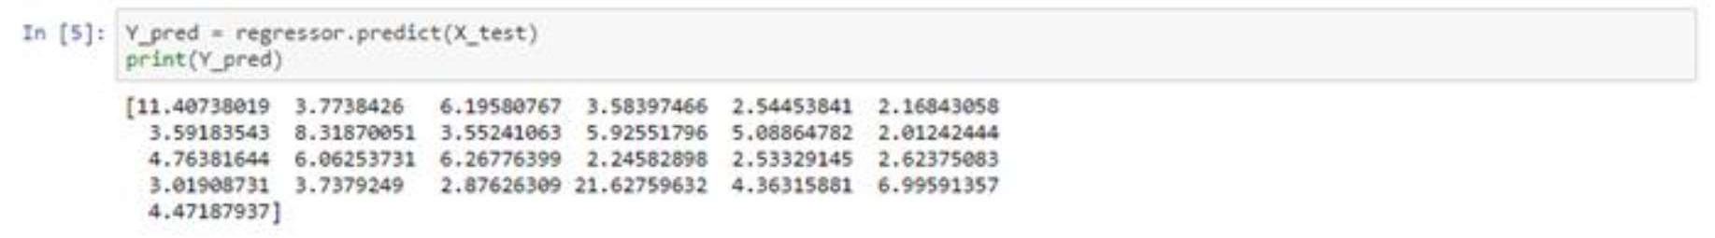

# VISUALISATION TRAINING RESULT

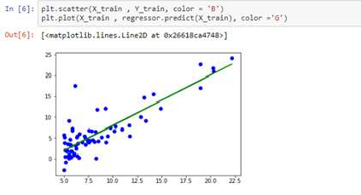

19

# VISUALISATION TESTING RESULT

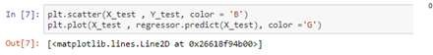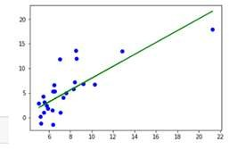

## Aim-9: Implement supervised machine learning algorithm (Classification Support Vector Machine) in python to classify breast tumour data into malignant breast tumour or benign breast tumour (use breast tumour dataset) and obtain its accuracy level.

# IMPORTING A LIBRARY & DATA PREPROCESSING

20

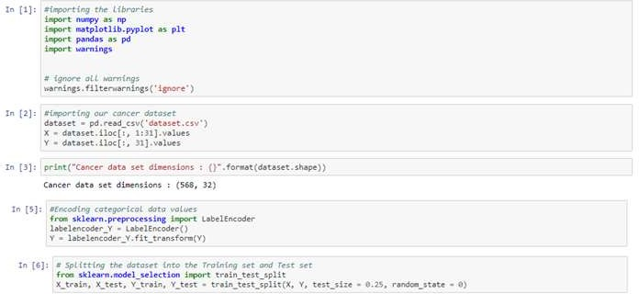

# FEATURE SCALING



# FITTING A UNSPERVISED LERANING ALGORITHM TO TRAINING SET

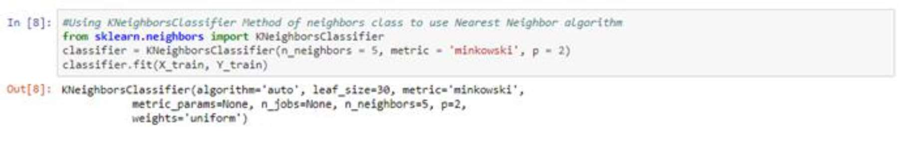

# RESULT PREDICTION

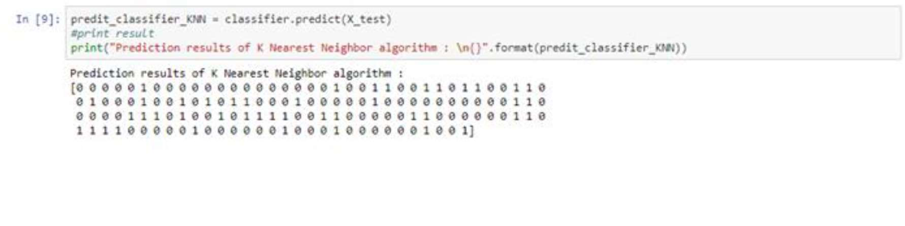

# CONFUSION MATRIX

21

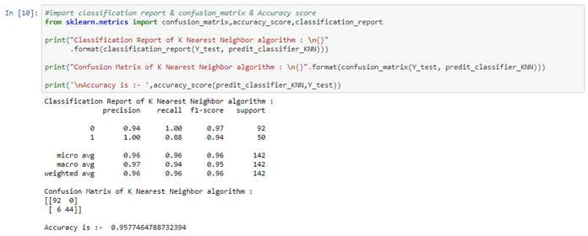

## Aim-10: Write a python program to build an email spam classifier using support vector machines for the Spam base dataset from UCI machine learning repository.

# IMPORTING LIBRARIES

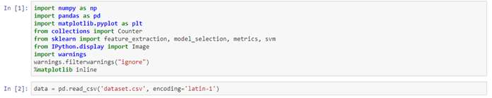

# DATA VISULAIZATION

22

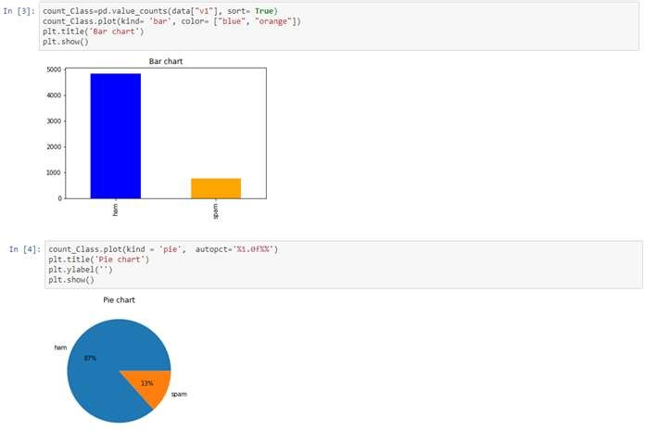

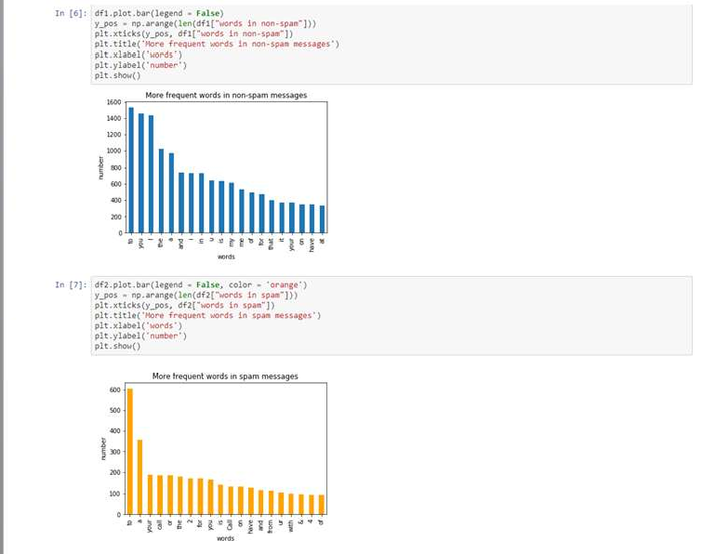

# MODEL FITTING

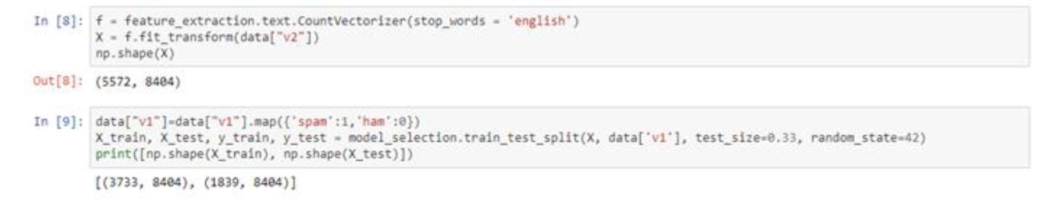

23

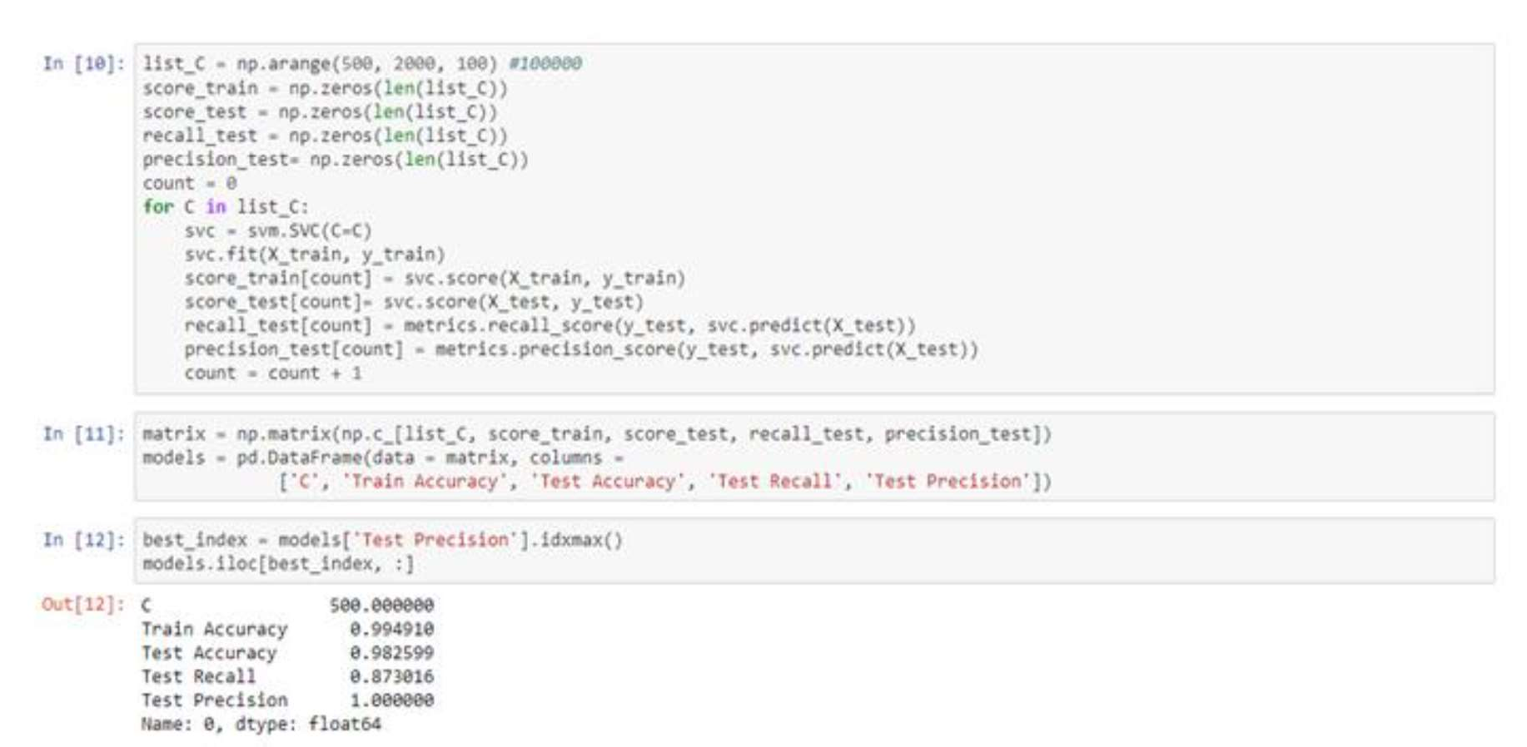

# FINAL PREDICTION:

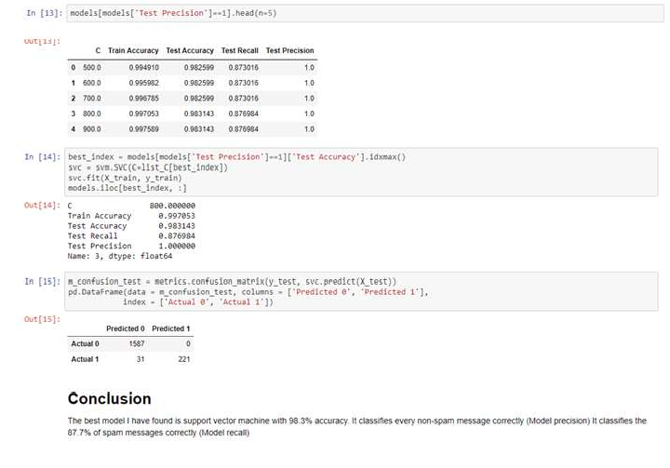

## Aim-11: Implement unsupervised machine learning algorithm (Clustering K Means) in python on Titanic dataset to cluster data (use Titanic dataset) by removing the class label.

# IMPORTING LIBRARIES & DATA PREPROCESSING

24

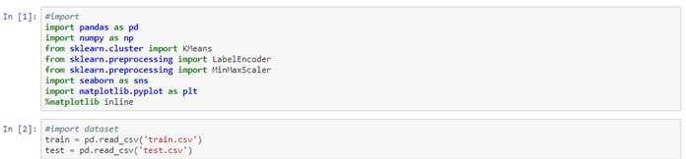

# DATA CLEANING



# VISUALIZATION

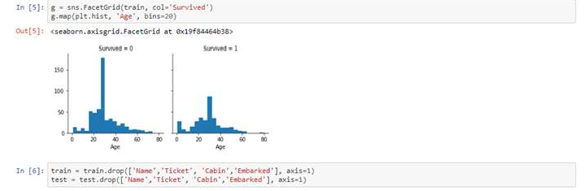

# SPLITING OF DATA

25

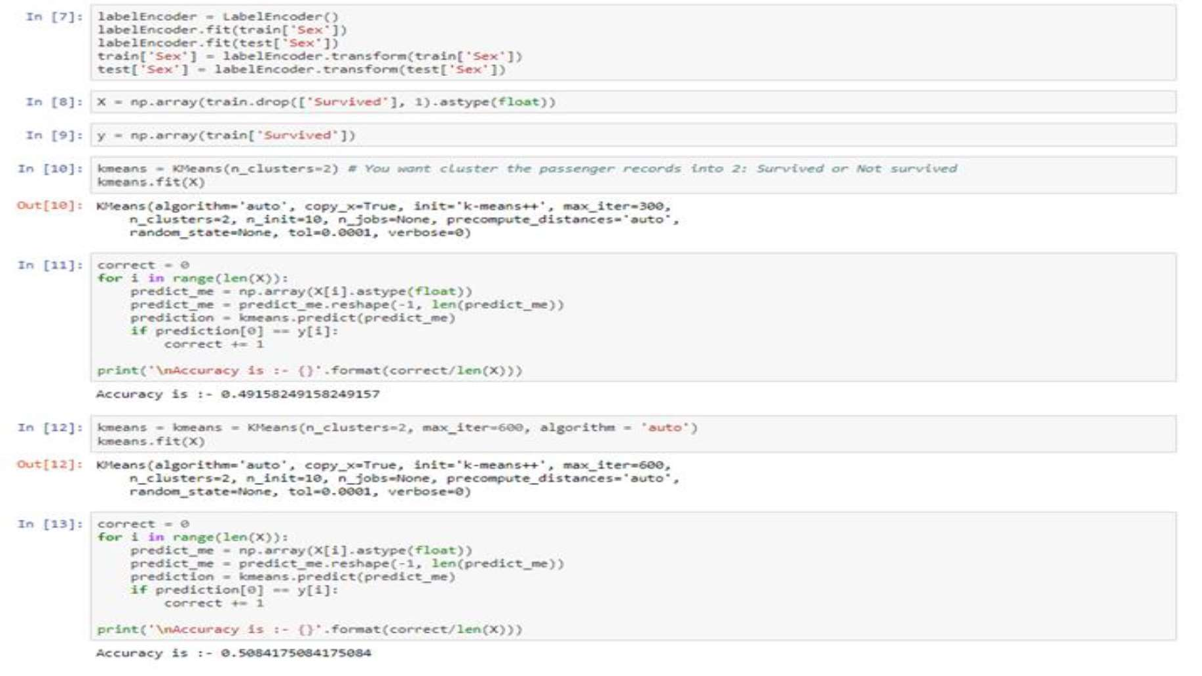

#APPLYING K-MEANS & FINAL PREDICTION:

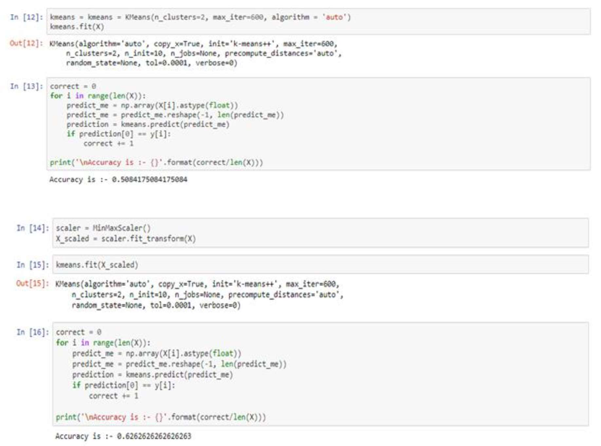

## AIM-12: Implement unsupervised machine learning algorithm (Clustering K Means) in

26

## python on Breast Tumour dataset to cluster data (use Breast Tumour dataset) by removing the class label.

# IMPORTING LIBRARIES

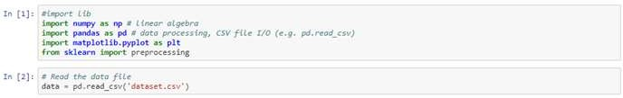

# CLEANING & MODIFYING DATA

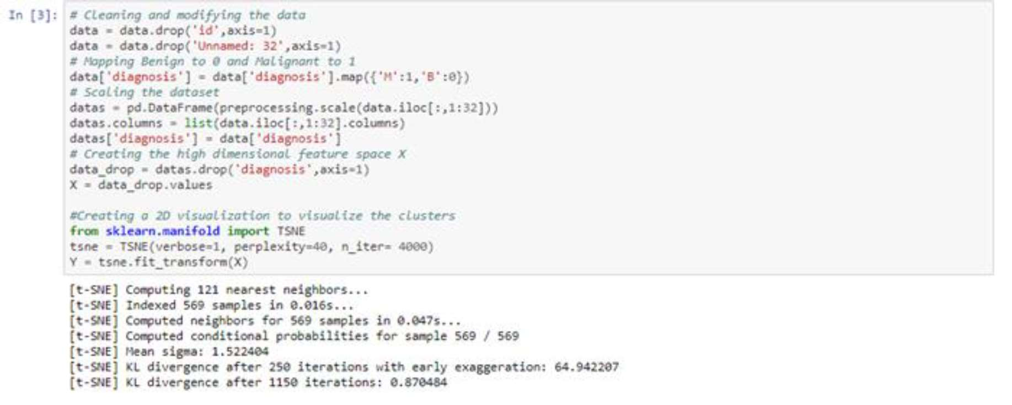

# DATA CLUSTERING

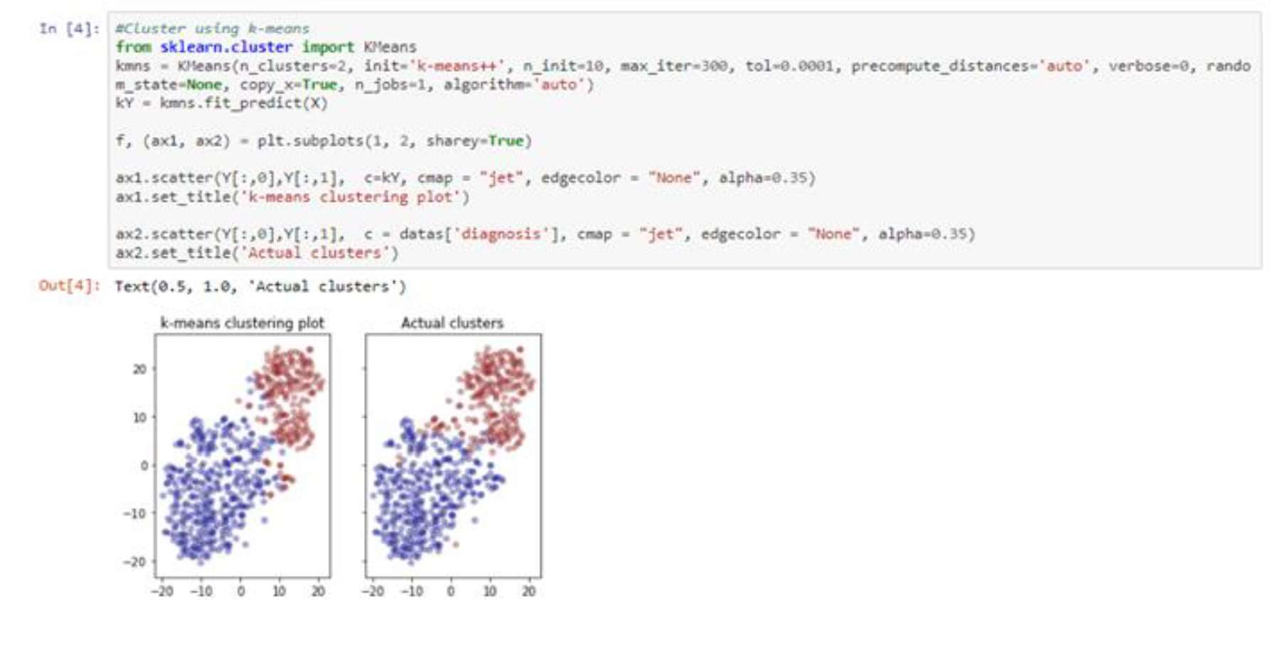

27

## AIM-13: Implement unsupervised machine learning algorithm (Clustering Hierarchical) in python on Titanic dataset to cluster data (use Titanic dataset)

# IMPORTING LIBRARIES & DATA PREPROCESSING

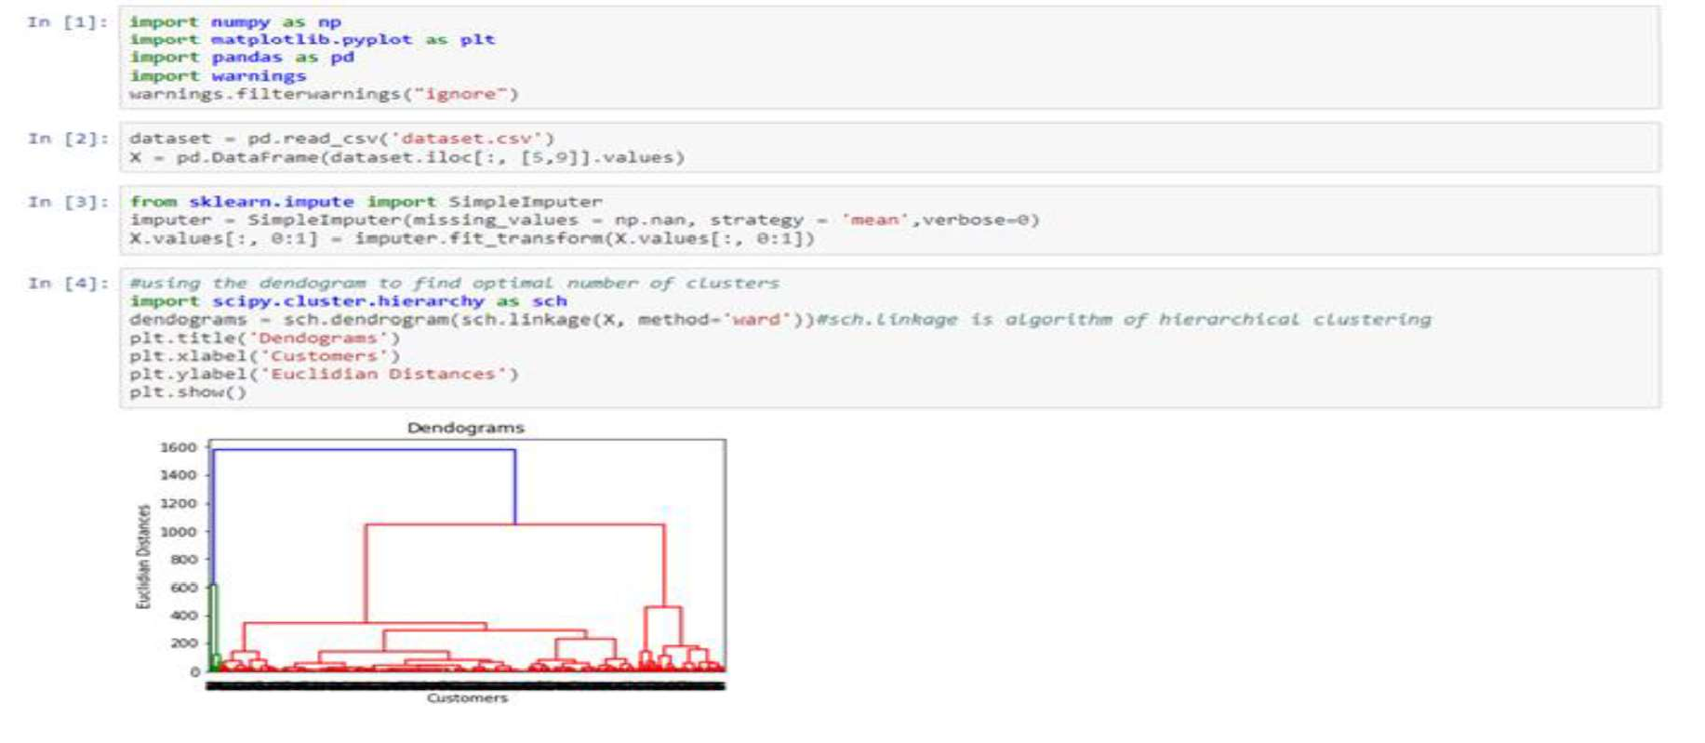

# MODEL FITTING AND SPLITTING DATA

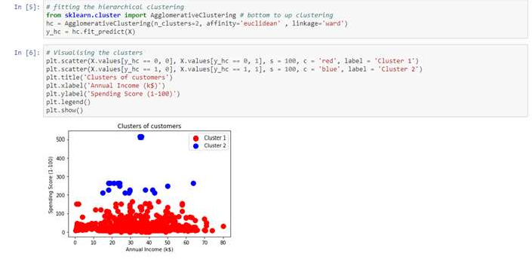

## AIM-14: Implement Apriori algorithm in python to find rules which explain association between different products for given transactions at a retail store.

#IMPORTING A LIBRARIES & DATA PREPROCESSING:

28

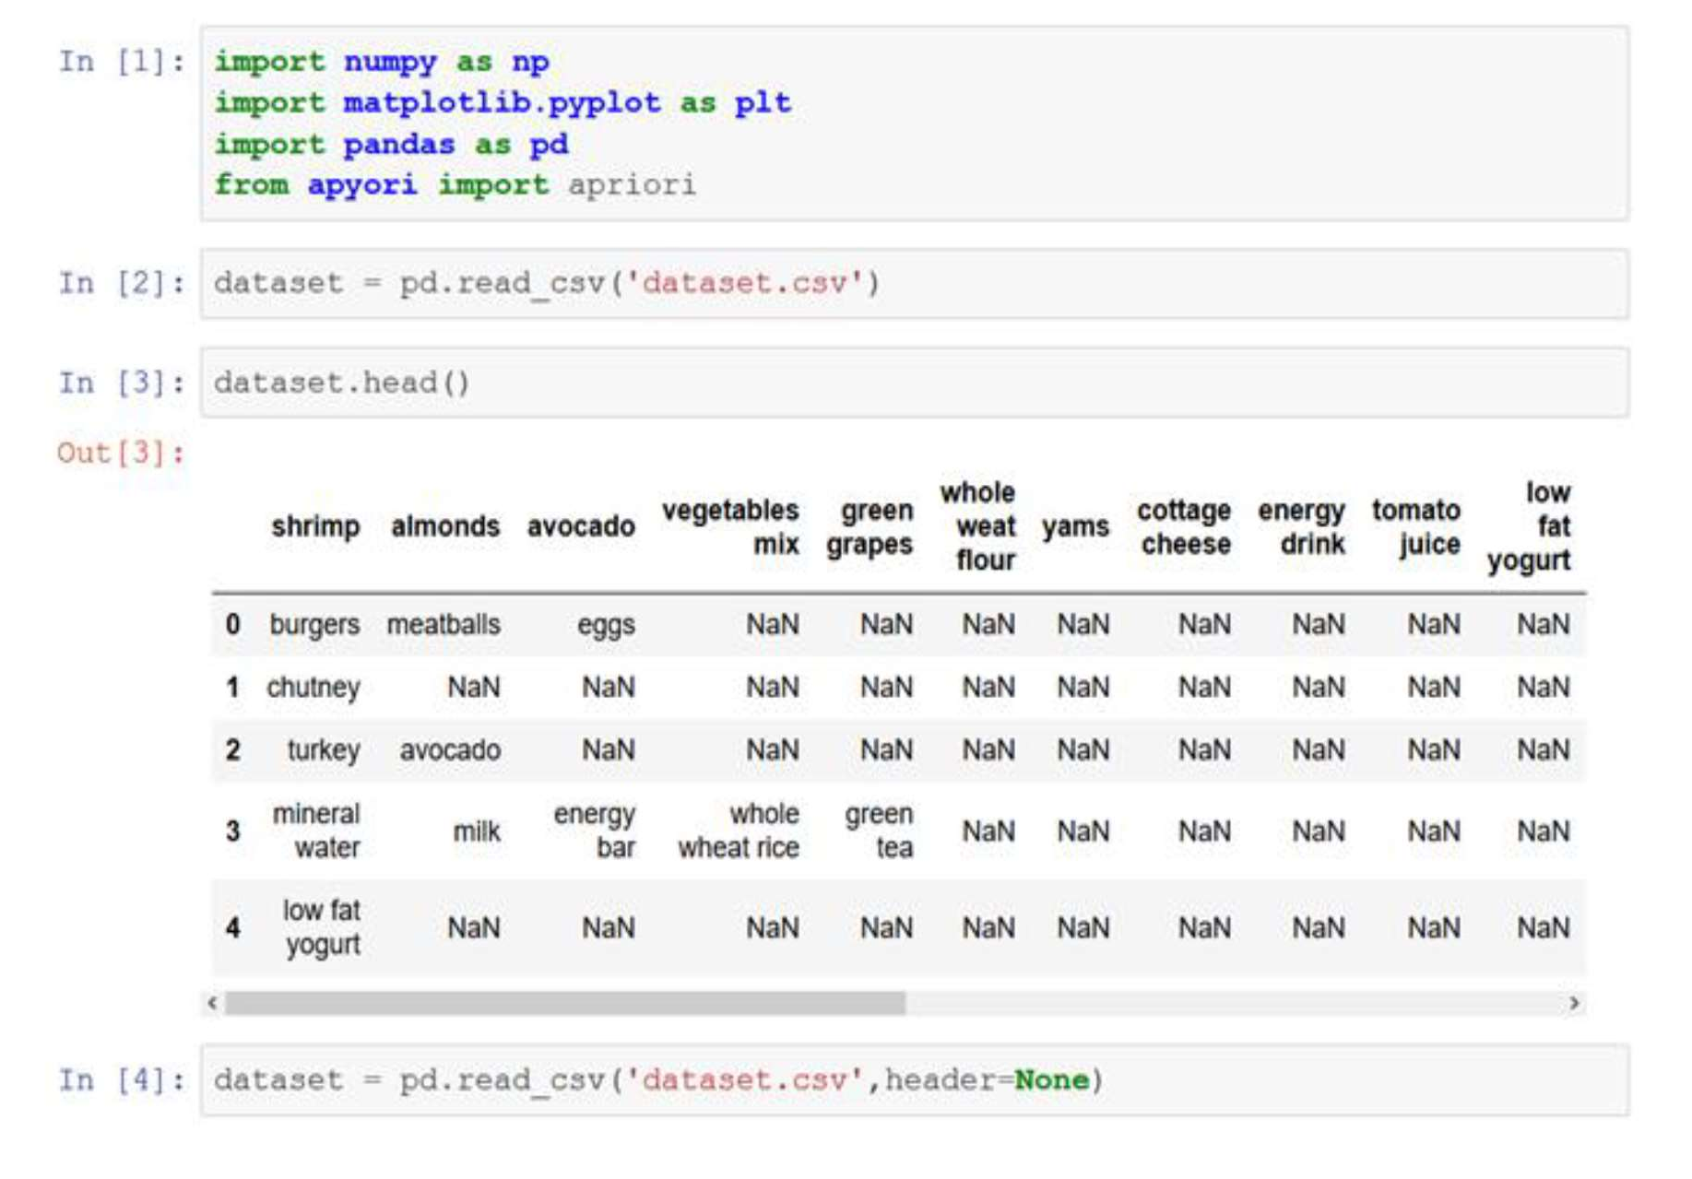

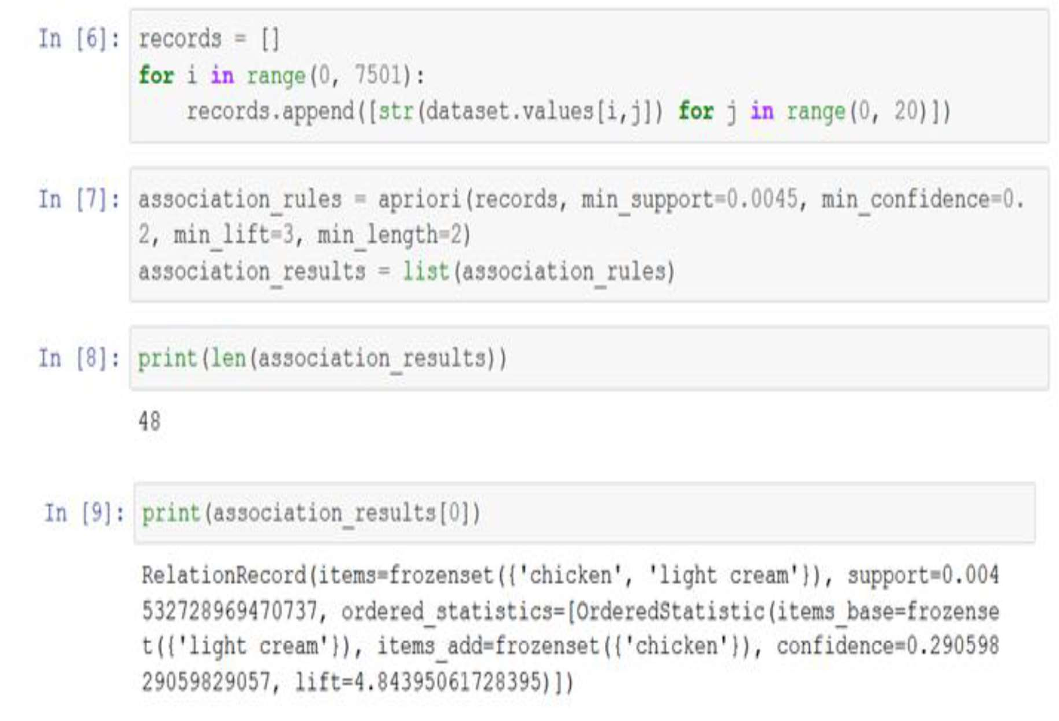

29

#FINAL RESULTS

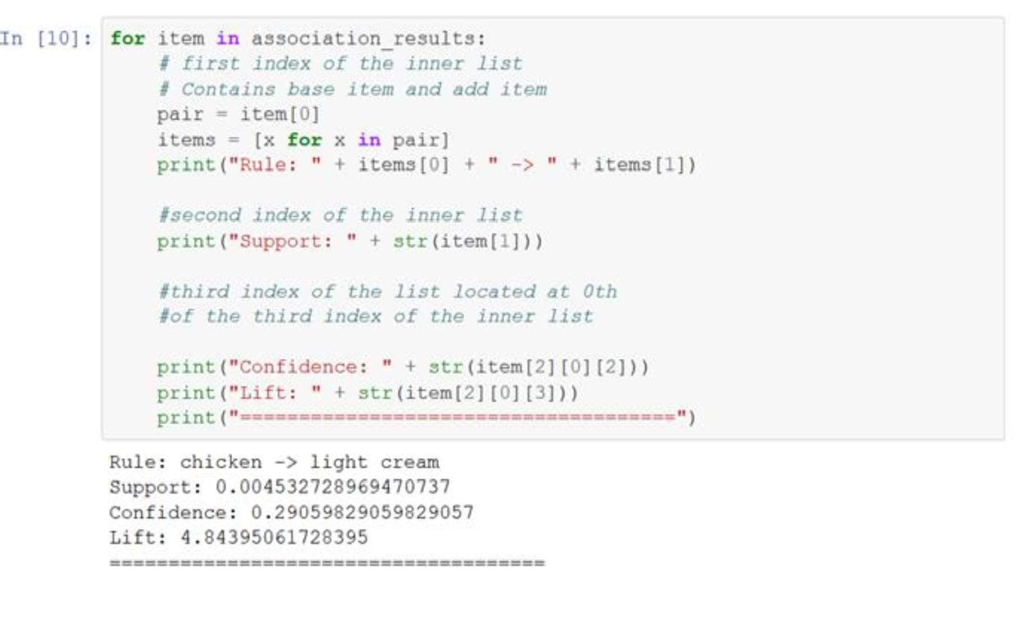

## AIM-15: Implement supervised machine learning algorithm (Classification - Naïve Bayes algorithm) in python/R on Pima Indians Diabetes dataset and obtain its accuracy level.

#IMPORTING LIBRARIES

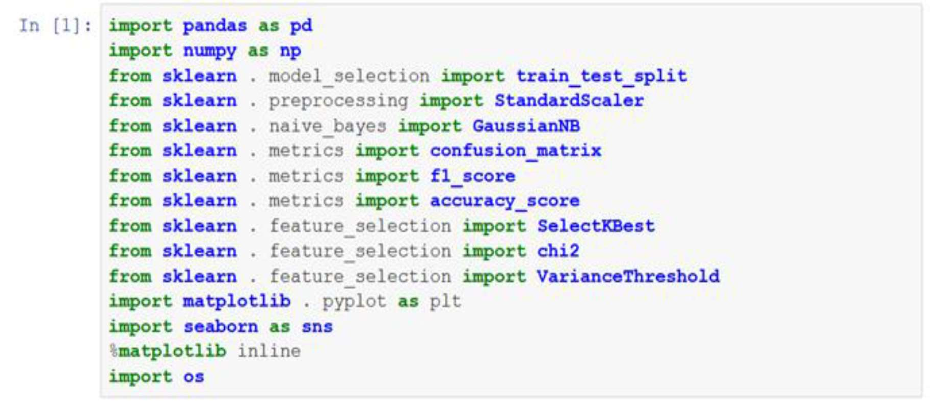

30

#DATA PROCESSING

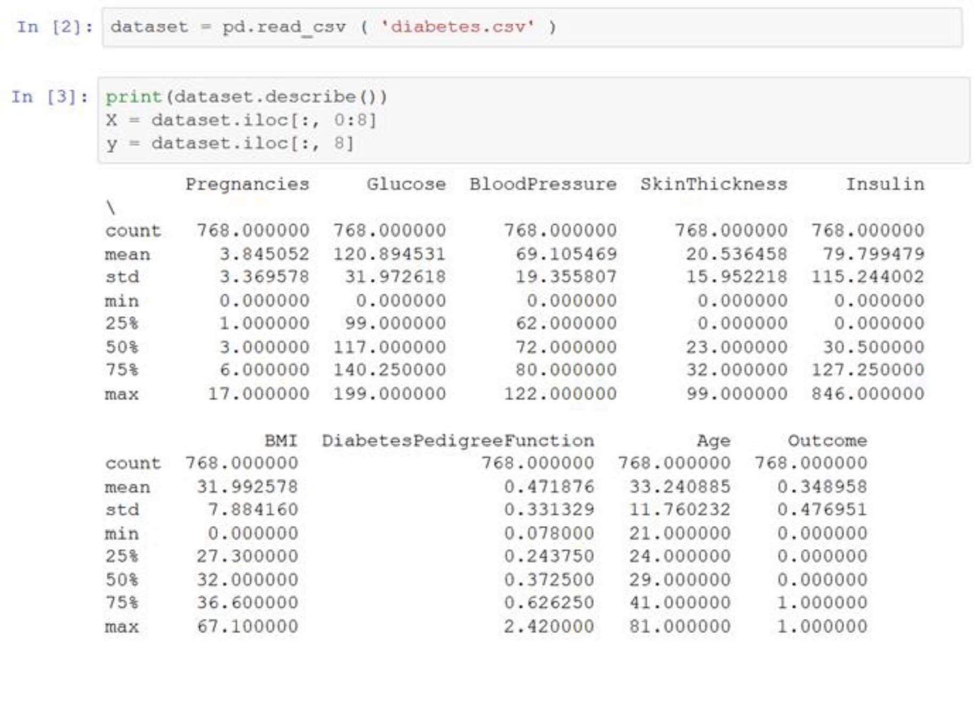

#HEAT MAP CORELATION VISUALIZATION

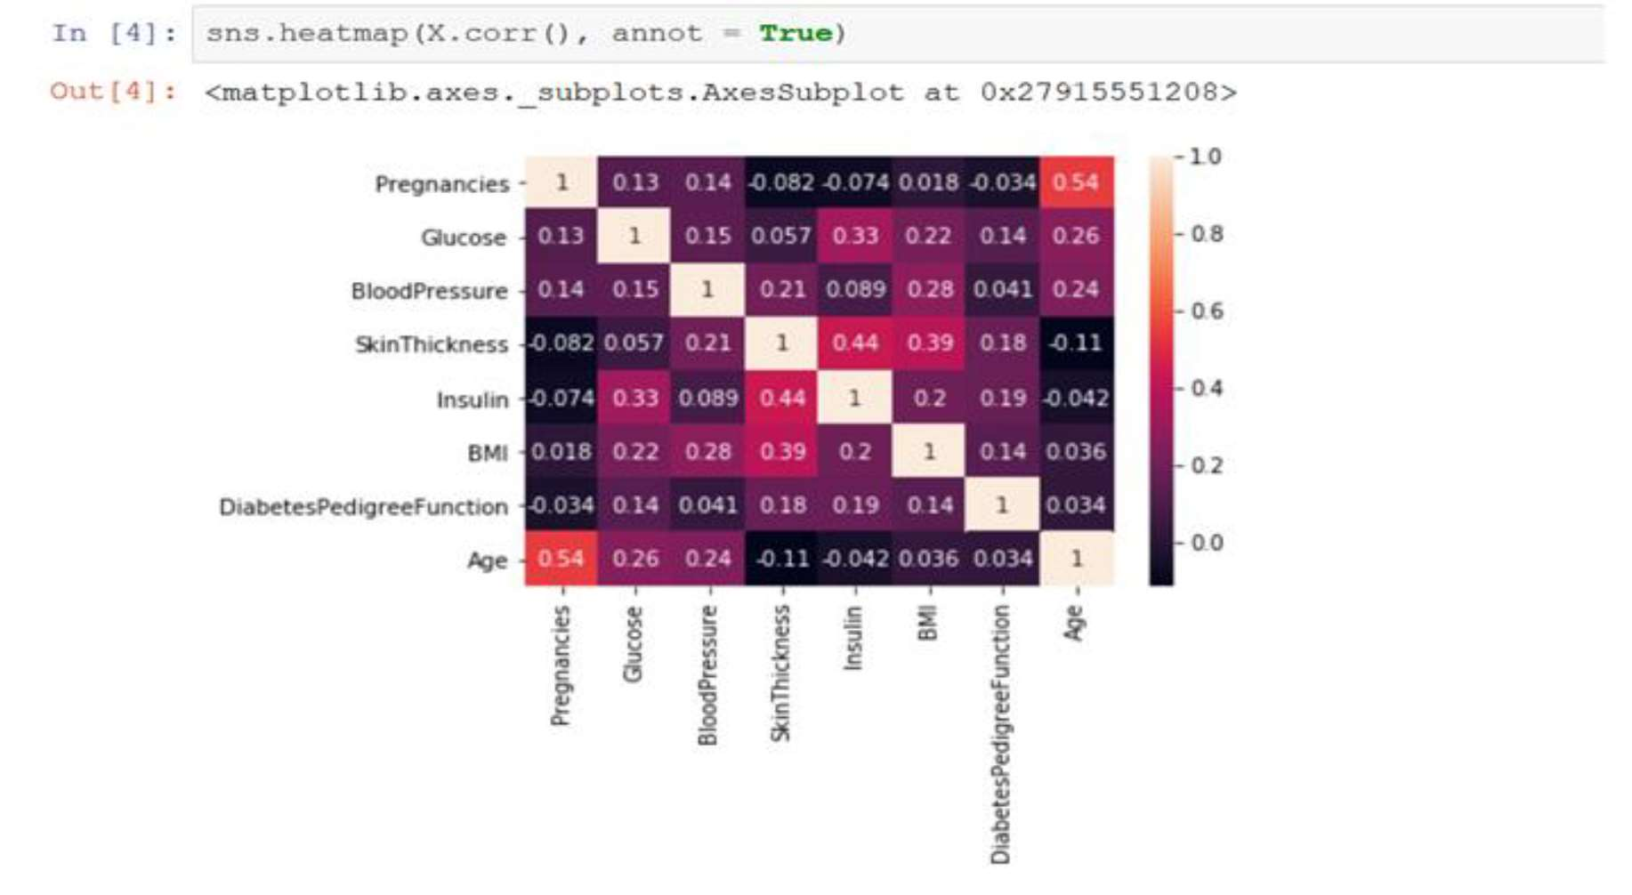

31

#DATA SPLITING:

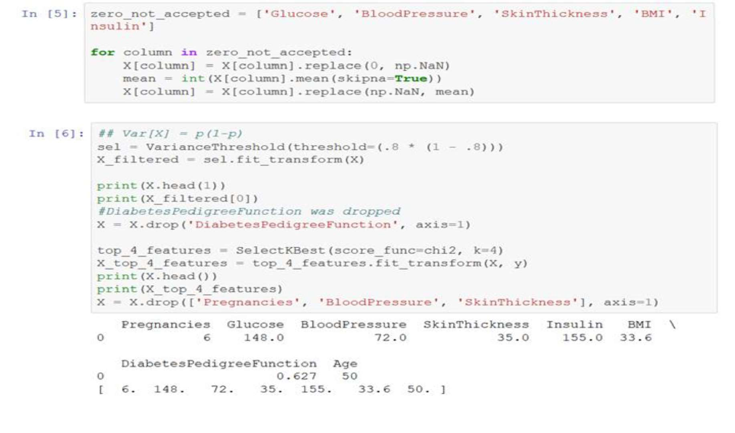

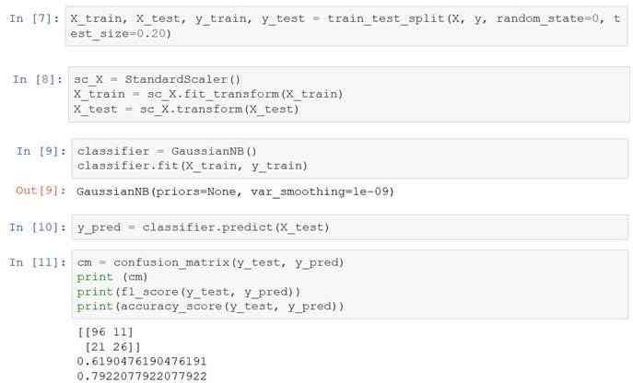

AIM-16: Implement unsupervised machine learning algorithm (Clustering K Means) in python. #IMPORTING LIBRARIES

32



#APPLYING K-MEANS

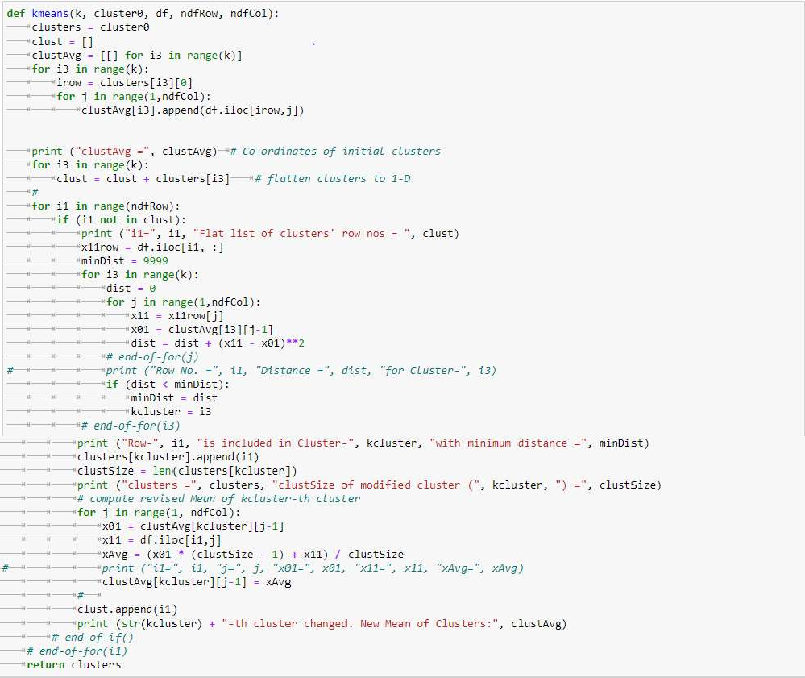

#DATABASE OPERATIONS:

33

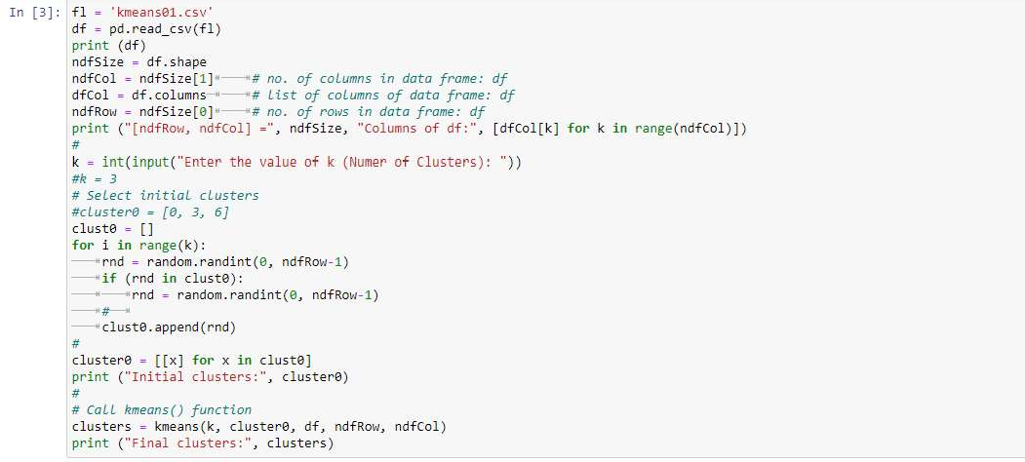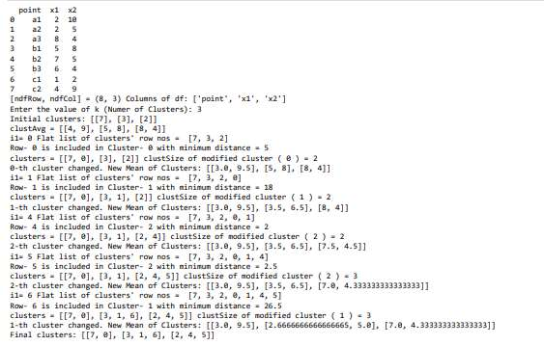

## AIM-17: Implement machine learning algorithm of Perception Learning in Artificial Neural Networks.

### TUTORIAL:

**Structure of two-layer feedforward neural network**

A perceptron is a model of a biological neuron. The input to a perceptron is an M-dimensional vector, and each component/dimension of the vector is scaled by a weight.

The sum of weighted inputs is computed and compared against a threshold. If the weighted sum exceeds the threshold, the output of the perceptron is '1'. Otherwise, the output of the perceptron is '-1' (or '0').

The output function of a perceptron is hard-limiting function. Thus the output of the perceptron is binary in nature.

34

The following figure illustrates a perceptron.

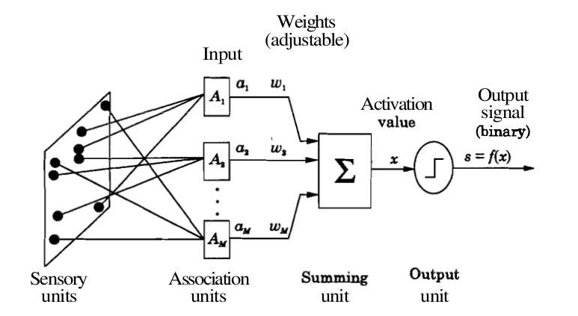

where M = number of the elements in the input vector

A two-layer feedforward neural network with hard-limiting output function for the unit in the output layer can be used to perform the task of pattern classification.

The number of units in the input layer is equal to the dimension of the input vectors. The units in the input layer are all linear units, and the input layer merely contributes to fan-out the input to each of the the output units.

The output layer may consist of one or more perceptrons. The number of perceptron units in the output layer depends on the number of distinct classes in the pattern classification task.

If there are only two classes, then one perceptron in the output layer is sufficient. Two perceptrons in the output layer can be used when dealing with four different classes in the pattern classification task.

Here, we consider a two-class classification problem, and hence only one perceptron in the output layer.

### Two-class pattern classification problem

Let us assume that one subset of input pattern vectors belong to one class, say, class \(A_1\), and the remaining subset of input pattern vectors belong to another class, say, class \(A_2\).

Let **a** = \( (a_1, a_2,...,a_M) \) denote an input pattern vector. The objective in a pattern classification problem is to determine a set of weights **w** = \((w_1, w_2,...,w_M) \), such that the weighted sum

$$ \sum\limits_{i=1}^{M} w_i a_i \gt \theta, \qquad(1)$$ if \( a \) belongs to \(A_1\), and

$$ \sum\limits_{i=1}^{M} w_i a_i \le \theta, \qquad(2)$$ if \( a \) belongs to \(A_2\). The dividing surface between the two classes is given by

$$ \sum\limits_{i=1}^{M} w_i a_i = \theta. \qquad(3)$$

This equation represents a linear hyperplane in the \( M \)-dimensional space. For two-dimensional input vectors, this equation represents a straight line.

The solution of the classification problem involves determining the weights and the threshold value, such that the resulting hyperplane acts as a dividing surface between the two classes.

35

This is achieved by means of a learning rule, which specifies the manner in which the weights and the threshold value need to be updated.

### Perceptron learning law

The goal of perceptron learning law is to systematically adjust the weights and the threshold in such a manner that a dividing surface between two classes is obtained. The perceptron learning law for a two-class pattern classification problem may be stated as follows:

**w**\((m+1) = \)**w**\((m) + \eta \) **a**, if **a** \(\epsilon A_1 \) and **w**\(^{T}(m).\)**a** \( \le 0, \) and

**w**\((m+1) = \)**w**\((m) - \eta \) **a**, if **a** \(\epsilon A_2 \) and **w**\(^{T}(m).\)**a** \( \gt 0. \qquad(4)\)

Here \( m \) denotes the index of iteration, or time step. Also, **a** and **w** are augmented input and weight vectors. That is

**a** = \((-1, a_1,a_2,...,a_M)\), and

**w** = \((\theta, w_1,w_2,...,w_M).\)

The term \( \eta \) denotes the learning rate, and can be set to a small value (say, 0.1 to 0.5). The value of \(

\eta \) can be varied in each learning step, although it is kept constant in perceptron learning. Note that the learning rule modifies the weights only when an input vector is misclassified.

When an input vector is classified correctly, there is no adjustment of weights and the threshold. When presenting the input vectors to the network (any neural network in general), we use a term called epoch, which denotes one presentation of all the input pattern vectors to the network.

To obtain suitable weights, the learning rule may need to be applied for more than one epoch, typically several epochs. After each epoch, it is verified whether the existing set of weights can correctly classify the input vectors.

If so, then the process of updating the weights is terminated. Otherwise the process continues till a desired set of weights is obtained. Note that once a separating hypersurface is achieved, the weights are not modified.

### Perceptron convergence theorem

This theorem states that the perceptron learning law converges to a final set of weight values in a finite number of steps, if the classes are linearly separable.

The proof of this theorem first assumes that there exists a set of weights which can correctly classify the input vectors. Then, a bound is obtained on the number of steps used to arrive at the optimum set of weights.

This can be illustrated by the figure below, where begining intially with a set of random weight, the decision boundary finally settles as a valid classifier in finite number of steps.

36

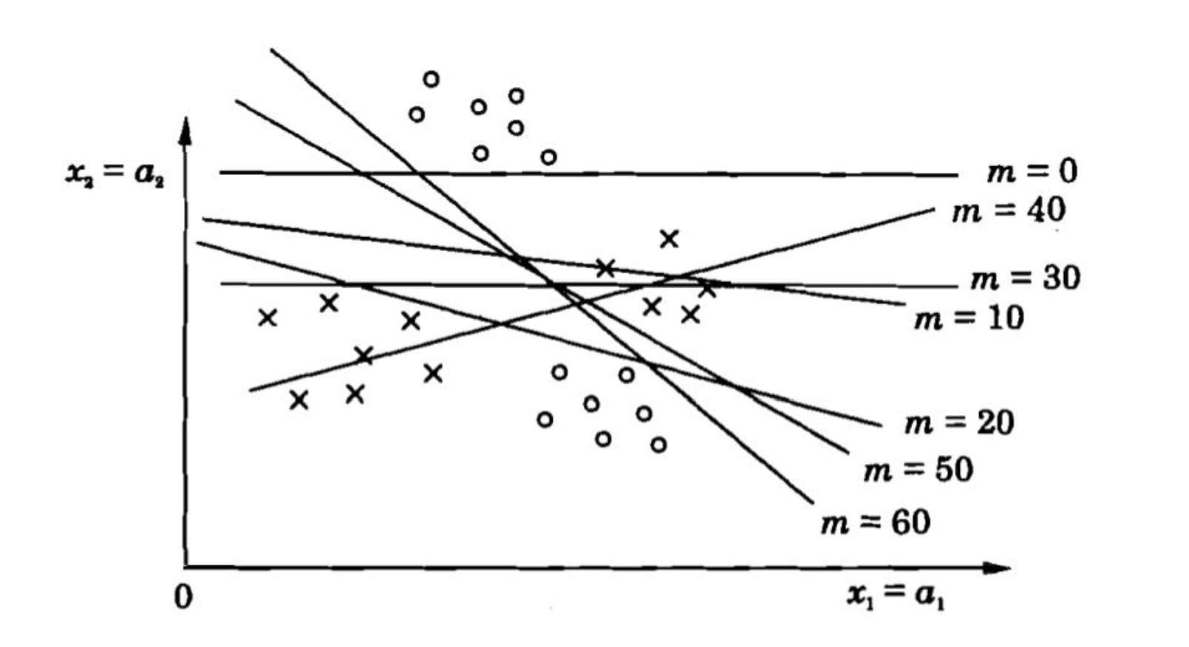

**Figure 2:** *Example to illustrate the perceptron convergence in pattern classification problem.*

### OBJECTIVE:

The objective of this experiment is to illustrate the concept of perceptron learning in the context of pattern classification task. Following are the goals of the experiment:

To demonstrate the perceptron learning law.

To illustrate the convergence of the weights for linearly separable classes.

To observe the behaviour of the neural network for two classes which are not linearly separable.

### ILLUSTRATION:

Consider two linearly separable classes, where each class consists of two-dimensional input pattern vectors. An example of two-class classification problem is shown below.

The input vectors belonging to each class are shown in different colours in the following figure. The line is defined by the equation \( w_1 x + w_2 y = \theta.\)

The straight line is defined by the initial values of the weights and the threshold.

37

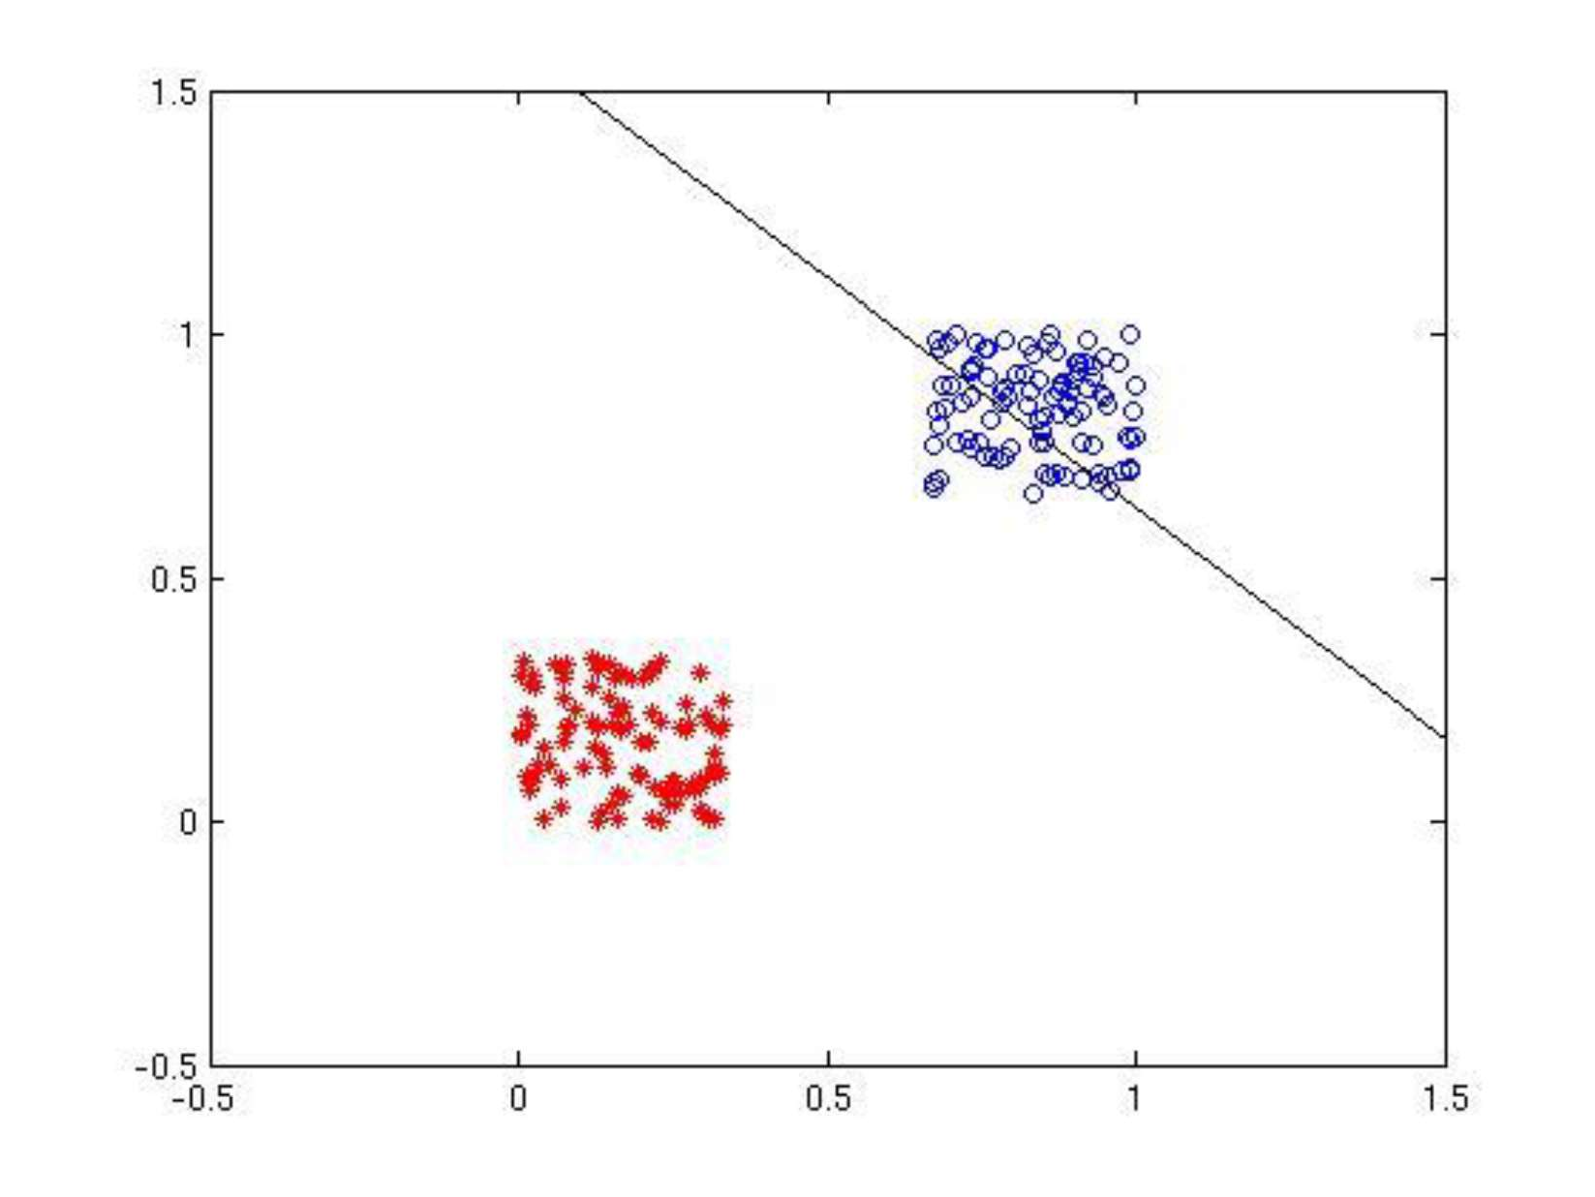

**Figure 1:** *Initial weights and the classes to be separated.*

After the convergence of weights, the line separates the two classes. This is shown in the following figure.

38

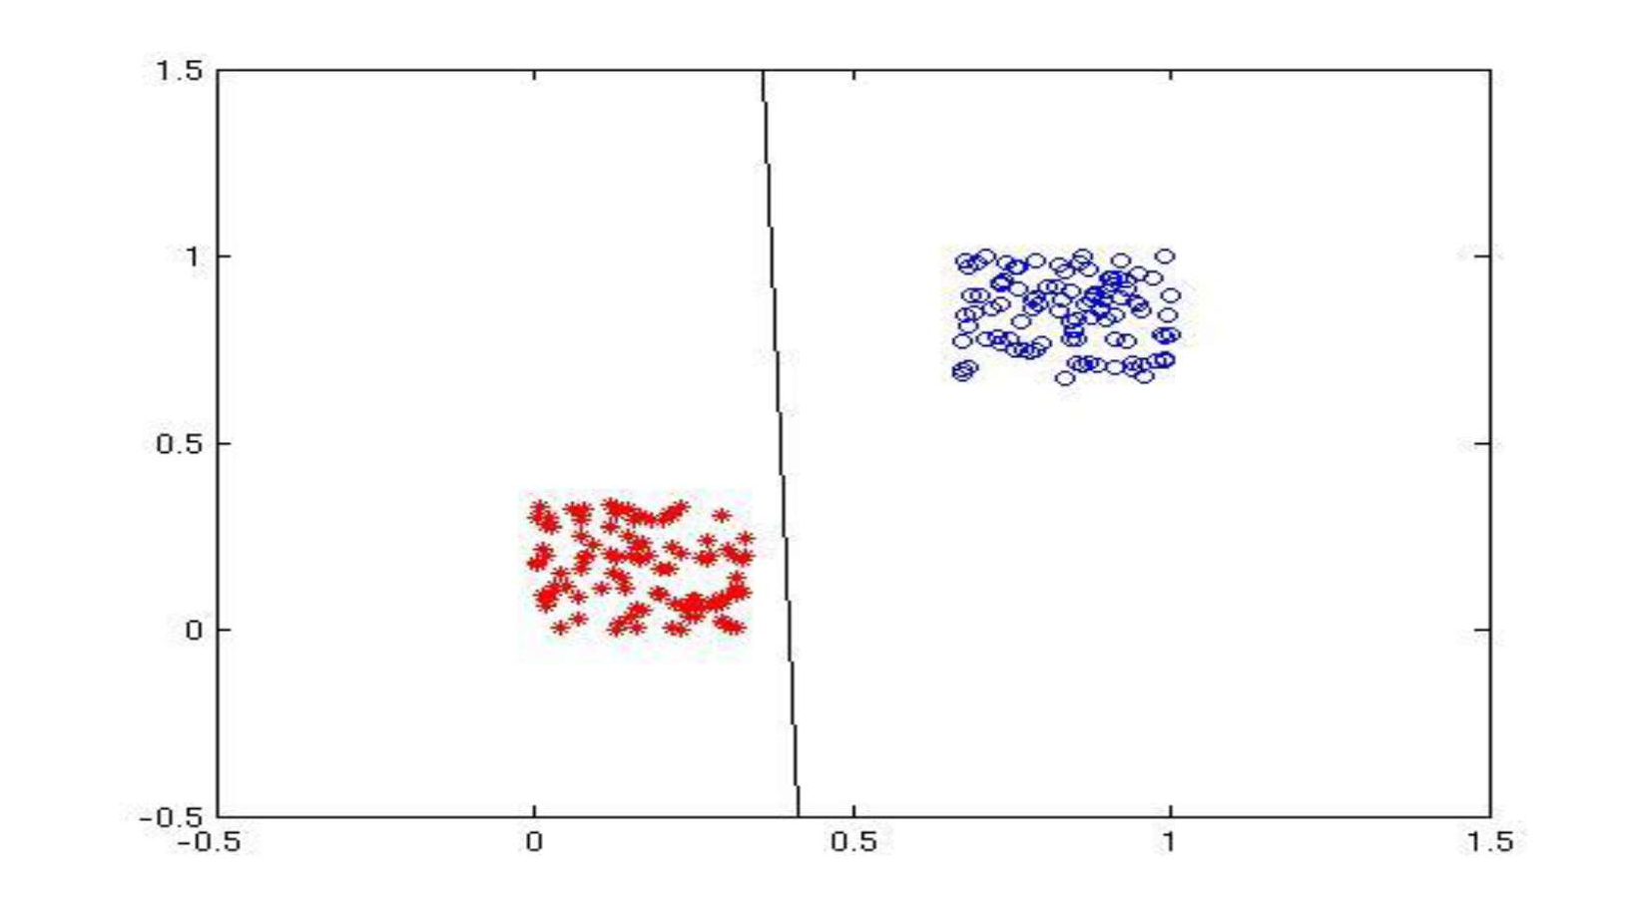

**Figure 2:** *After the weights have converged, the final values of weights determine the line separating the classes.*

# Convergence of weights and threshold value

The following figures show the variation of threshold \( \theta \), and the weights \( w_1 \) and \(w_2\), as functions of the iteration index.

The convergence of \( \theta, w_1 \) and \( w_2 \) can be noted.

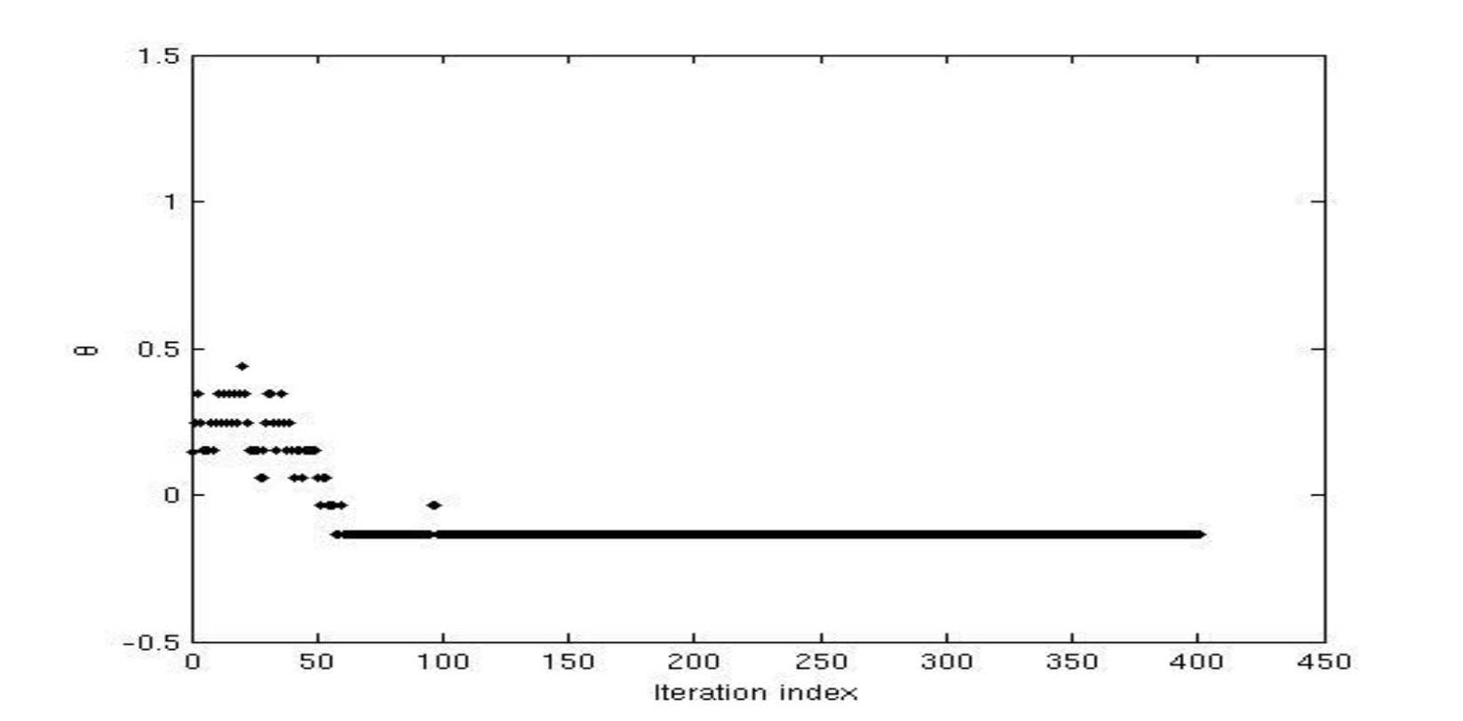

**Figure 3:** *The variation in values of \(\theta\) with iterations as network reaches convergence*

39

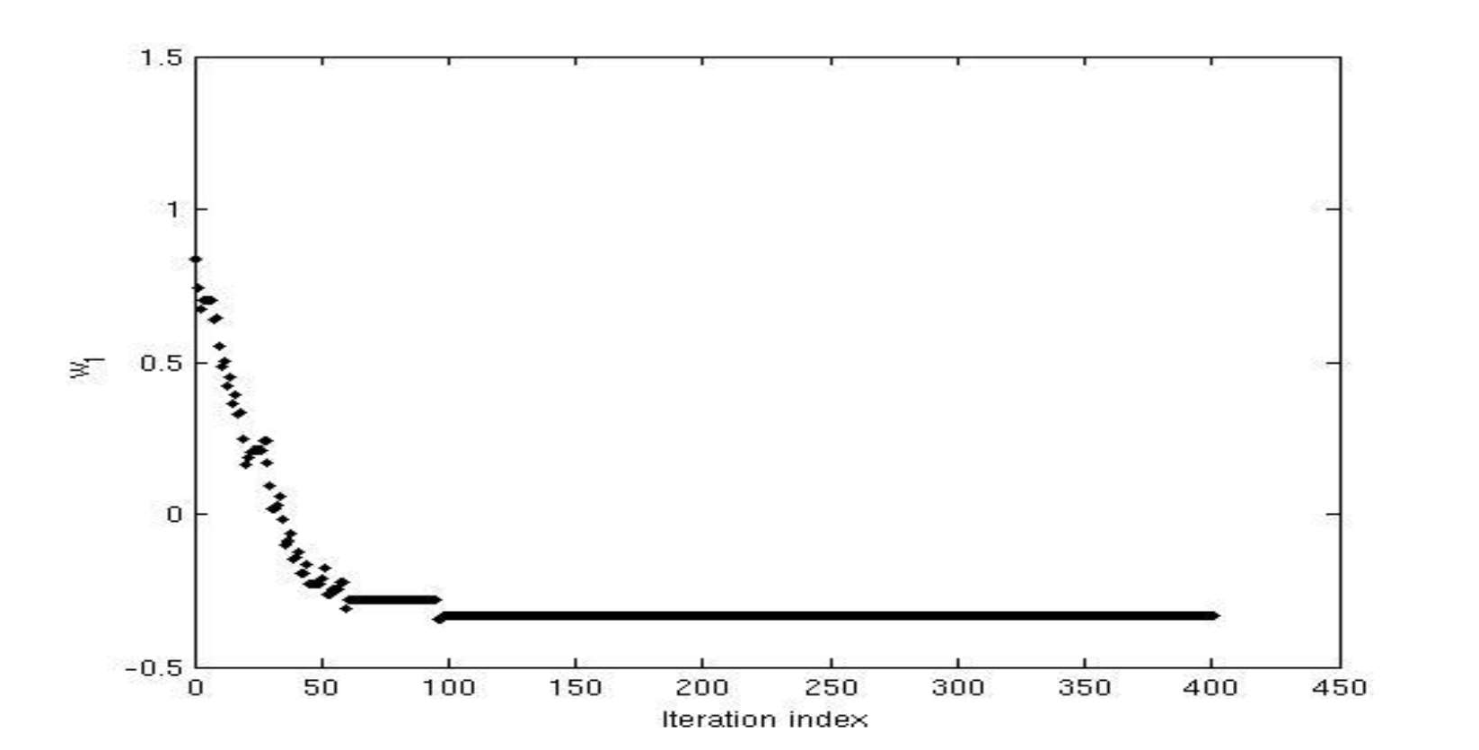

**Figure 4:** *The variation in values of weight \(w_1\) with iterations as network reaches convergence.*

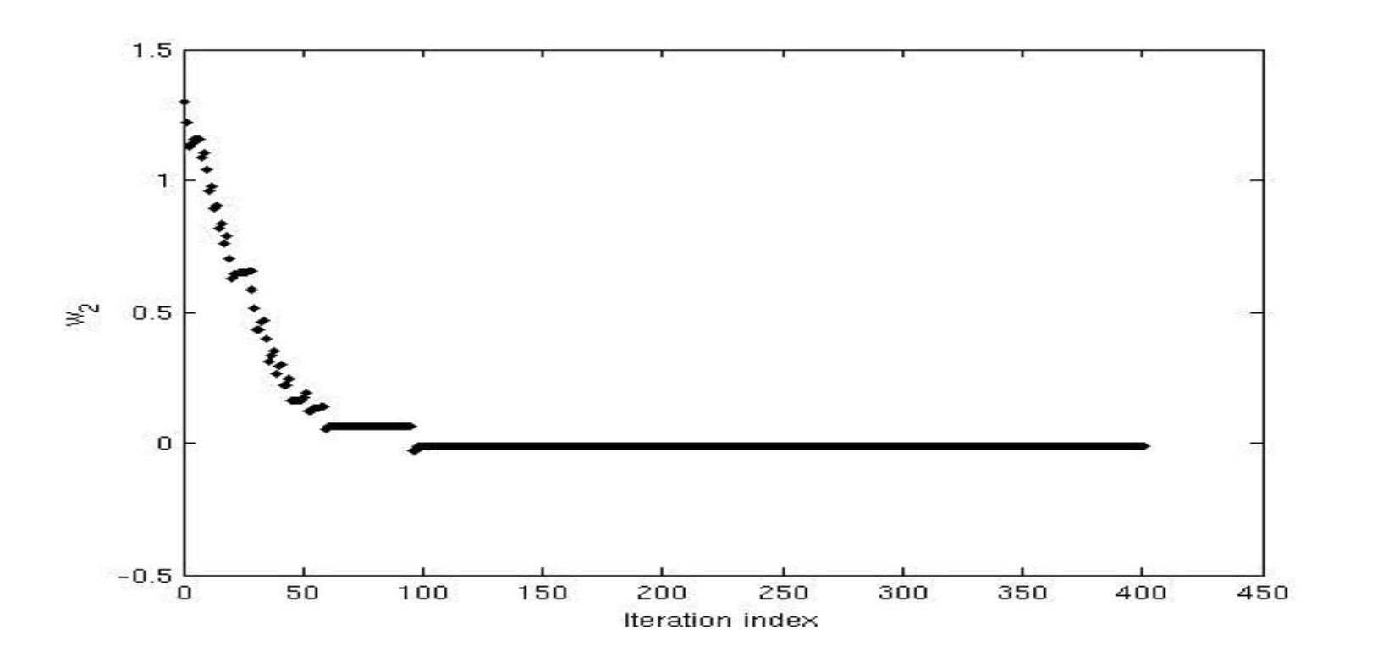

**Figure 5:** *The variation in values of weight \(w_2\) with iterations as network reaches convergence.*

## AIM-18: Implement machine learning algorithm of Multilayer feedforward in Artificial Neural Networks.

### TUTORIAL:

**Architecture of multilayer feedforward neural network**

It can be shown that a multilayer feedforward neural network (MLFFNN) with at least two intermediate layers in addition to the input and output layers can perform any pattern classification task.

For this to be true, the units in the hidden layers and the output layer must be nonlinear in nature. Such an MLFFNN can be used for pattern mapping tasks.

Given a set of input-output pairs of pattern vectors, the task of pattern mapping involves determining the set of weights which can transform the input vectors into the output vectors.

40

Thus, a systematic way of updating the weights is required. To update the weights in a supervised manner, is necessary to know the desired output for each unit in the hidden and the output layers.

Once the desired output for a unit is known, the error between the desired output and the actual output can be computed. This error, in turn, can be used to modify the weights associated with the unit.

However, the desired output is known only for the units in the output layer, and not for the units in the hidden layers. This issue is addressed by employing backpropagation algorithm.

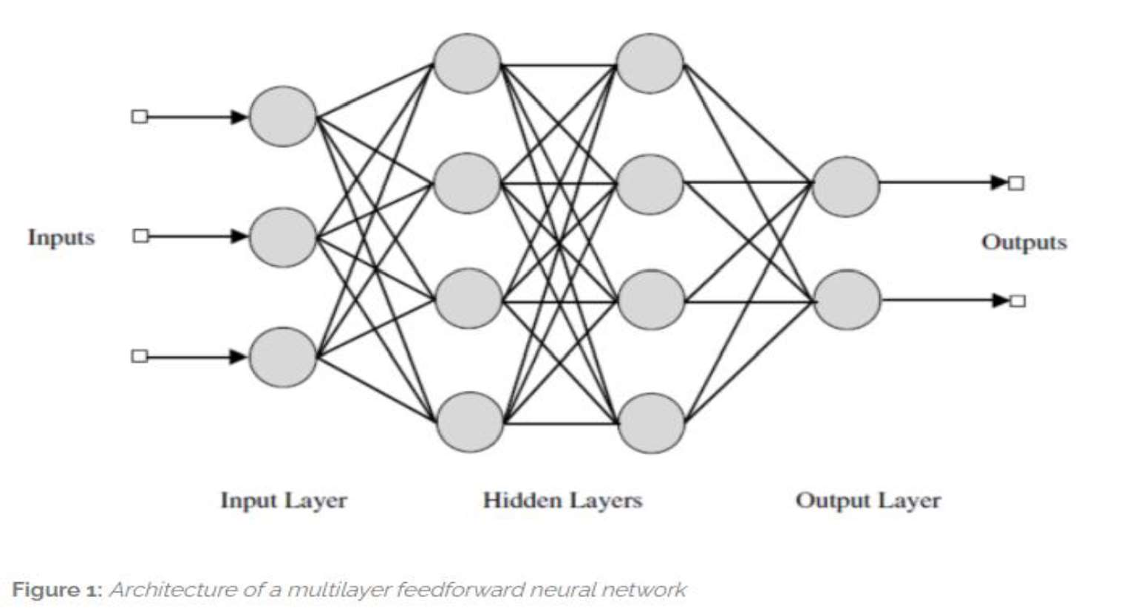

### Backpropagation learning rule for modifying the weights of MLFFNN

Nature of error surface

In order to obtain the desired outputs for units in the hidden layer, the approach followed is the gradient descent along the error surface.

The error is defined as the squared difference between the desired output pattern (which is the given output vector) and the actual output vector obtained at the output layer of the network, given an input pattern.

Note that the application of an input pattern produces an output pattern from the network. The sum of errors obtained for each input-output pattern pair can be considered as the overall error.

The overall error is a function of all the weights of the MLFFNN. All the weights of the MLFFNN can be represented as a weight vector.

The weight vector is a point in the multidimensional weight space. Thus, the overall error as a function of the weight vector can be viewed as an error surface, for different values of the weight vector.

The goal is to obtain that value of the weight vector which results in a minima on the error surface. Thus, the weights need to be modified in a manner so as to traverse the error surface in such a way that the minimum is achieved.

### Generalized delta rule

The rule is basically a gradient descent along the the error surface. For a given set of input-output pattern pairs, the overall error is computed. Note that the overall error is a function of the weight values.

What is required is the gradient of the error surface with respect to the weights. Once the gradient is obtained, the weights can be modified such that the error surface is traversed in a direction that is against the

41

gradient.

The overall error is differentiated with respect to the weights leading to the output layer, and with respect to the weights of the hidden layers. This results in an expression for the gradient, whose negative is used to modify the weights.

Note that the units in the hidden layer and the output layer need to be differentiable, because the overall error is differentiated with respect to the weights. The increment in the weight connecting the units \(j\) and

\(i\) is given by:

$$ \Delta w_{ij}(m) = -\eta\frac{\partial E(m)}{\partial w_{ij}}, \qquad(1)$$

where \(m\) is the step number and \(\eta \gt 0\) is a learning rate parameter, which may also vary for each presentation of the training pair.

### Discussion on backpropagation rule Features of backpropagation

The key idea is the backpropagation of error from the output layer to the hidden layers, which is possible because of the nonlinear nature of the units.

If the units were to be linear, the MLFFNN transforms into a linear associative network, and its ability to generate complex decision boundaries to solve nonlinearly separable classification problem is lost.

The modification of weights can be done in a pattern mode or in a batch mode. In the pattern mode, the weights are updated once for every input vector. In the batch mode, the weights are updated once after all the input vectors have been presented to the network.

There is no proof of convergence of the backpropagation learning. Some heuristic criteria are used to stop the process of learning.

### Performance of backpropagation learning

The performance of backpropagation learning law depends on the initial settings of the weights, learning rate parameter, output functions of the units, and presentation of the training data.

The performance also depends on the specific pattern recognition task (such as classification and mapping), or specific application (such as function approximation and probability estimation).

The value of the learning rate depends on the distribution of the input data. The learning rate can be changed as a function of the iteration.

A number of refinements can be added to the backpropagation learning, in order to speed up the learning.

### OBJECTIVE:

The objective of this experiment is to demonstrate the ability of a multilayer feedforward neural network (MLFFNN) in solving linearly inseparable pattern classification problems.

### ILLUSTRATION:

Consider two linearly inseparable classes, where each class consists of two-dimensional input pattern vectors.

42

An example of two-class classification problem is shown below.

The input vectors belonging to each class are shown in different colours in the following figure (Figure 1).

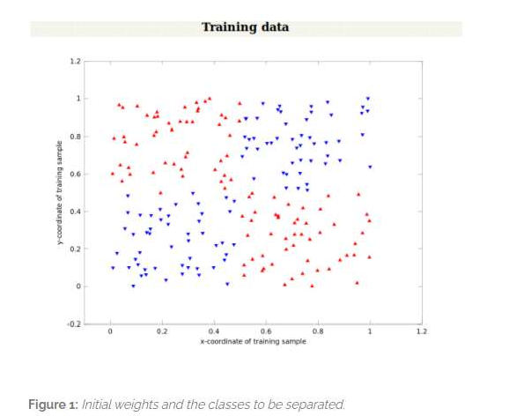

The mean squared error obtained during training as a function of the number of iterations is shown in the following figure (Figure 2)

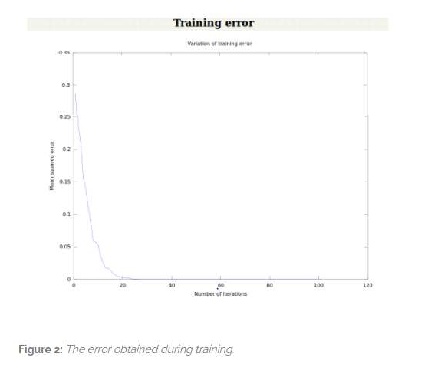

### Convergence of weights and threshold value

43

The following figure (Figure 3) shows the initial data and the classification of the test data.

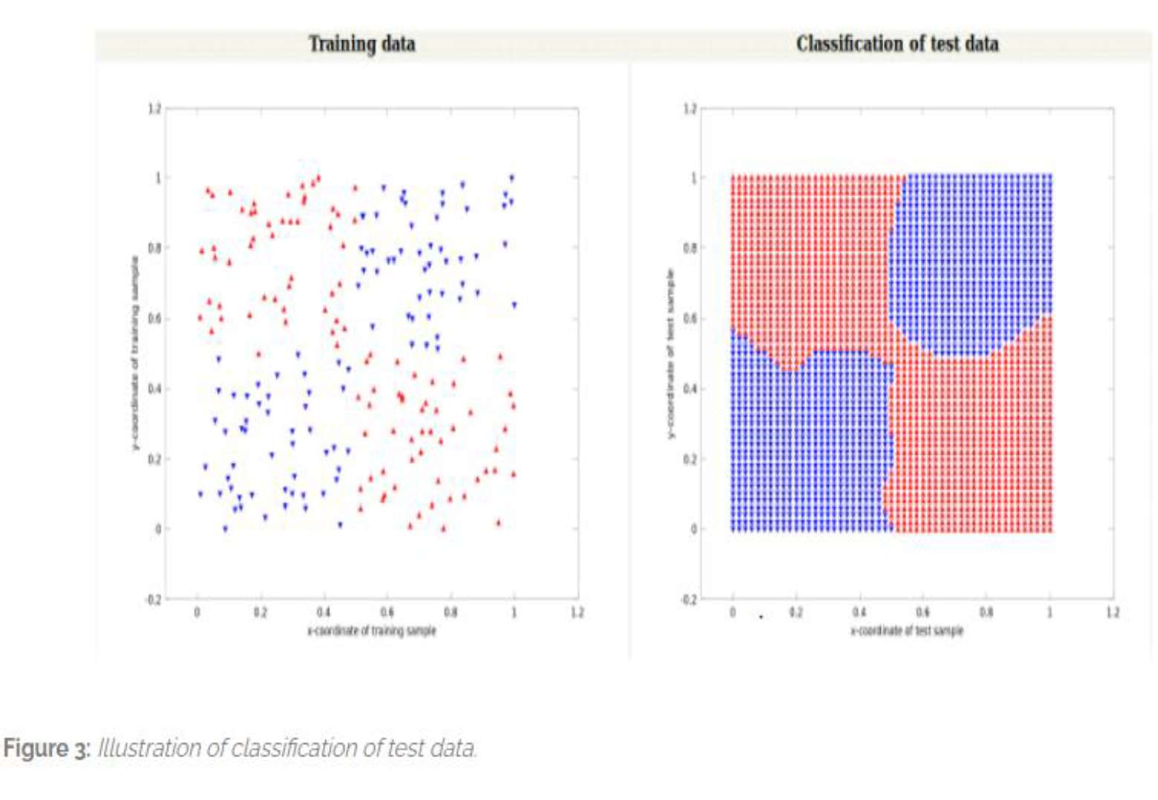

44